D5.4
Communication, Dissemination, Standardisation and Exploitation Report 2 - public version
INTEL

Version v1
Work package | WP5
Task | T5.1, T5.2, T5.3, T5.4
Deliverable lead | INTEL
Version | v1.0
Authors | All consortium partners
Reviewers | Valerio Frascolla (INT), Antonio De La Oliva (UC3M)

Abstract
This deliverable reports on all WP5 activities performed by all consortium partners till the end of the project. This is a stripped-off version, where sensible parts have been removed.

Keywords
Dissemination, communication, exploitation, standardisation, innovation, impact

Disclaimer
The information, documentation and figures available in this deliverable are provided by the PREDICT-6G project consortium under EC grant agreement 101095890 and do not necessarily reflect the views of the European Commission. The European Commission is not liable for any use that may be made of the information contained herein.
Copyright notice
©PREDICT-6G 2023-2025

Project co-funded by the European Commission in the Horizon Europe Programme
Nature of the deliverable |  | R
Dissemination level
PU | Public, fully open. e.g., website | ✔
CL | Classified information as referred to in Commission Decision 2001/844/EC
SEN | Confidential to PREDICT-6G project and Commission Services

* Deliverable types:
R: document, report (excluding periodic and final reports).
DEM: demonstrator, pilot, prototype, plan designs.
DEC: websites, patent filings, press and media actions, videos, etc.
OTHER: software, technical diagrams, etc.
Table of contents
Executive summary 12
1 Introduction 13
2 Communication and Dissemination 14
2.1 Overall strategy performance and update 14
2.2 Communication activities in Year 2 and 3 15
2.2.1 Digital tools 16
2.2.1.1 Project website 16
2.2.1.2 Social media 17
2.2.1.3 Online repository: ZENODO 22
2.2.2 Online articles, newsletters and press releases 22
2.2.2.1 Online articles 22
2.2.2.2 Newsletters 23
2.3 Dissemination activities in Year 2 and 3 26
2.3.1 Scientific Publications and Conferences 26
2.3.1.1 Scientific Journals 26
2.3.1.2 Scientific Conferences, Workshops, and Panels 27
2.3.1.3 Technical publications 38
2.3.2 Events, conferences and workshops (non-peer reviewed) 39
2.3.3 PREDICT-6G Multimedia 41
2.3.3.1 Promotional material 41
2.3.3.2 Videos 45
2.4 Ecosystem building and stakeholder management 46
2.4.1 PREDICT-6G and HORIZON-JU-SNS-2022-STREAM-B-01-01 funded projects 46
2.4.2 PREDICT-6G and the SNS ecosystem 57
3 Standardisation 59
3.1 Project Innovations to SDO Mapping 59
3.2 Standardisation Contribution 61
4 Exploitation and Innovation 66
4.1 Exploitation 66
4.1.1 IP and patents 66
4.1.2 Partner-Specific exploitation plans updates 66
4.2 Innovation 66
4.2.1 Innovation Programme 66
4.2.1.1 First Innovation Workshop, Bucharest 10.2023 67
4.2.1.2 Second Innovation Workshop, Madrid 01.2025 69
4.2.2 Innovation per WP 71
4.2.2.1 Innovation related to WP2 73
4.2.2.2 Innovations related to WP3 74
4.3 Exploitation Workshop 75
4.4 Open Science (OS) 76
5 Conclusions 78
6 Appendixes 79
6.1 Appendix 1: Scientific publications in journals 79
6.2 Appendix 2: List of online articles 80
6.3 Appendix 3: List of publications in Zenodo 83

List of figures
Figure 1. PREDICT-6G website 16
Figure 2. Top visited pages in PREDICT-6G website 17
Figure 3. PREDICT-6G profile in LinkedIn 18
Figure 4. PREDICT-6G campaign to promote its outcomes 19
Figure 5. "Women in Science" and “Europe Day” campaigns 19
Figure 6. "In the spotlight” campaign 20
Figure 7. "PREDICT-6G Farewell” campaign 21
Figure 8. LinkedIn visitors demographics 21
Figure 9. Visual promoting the PREDICT-6G newsletter. 23
Figure 10. Booth background designed by AUS 29
Figure 11. UPC and TID team at ICTON 2024 31
Figure 12. Pietro Giardina (Nextworks) at EFTA 2024 32
Figure 13. Left: Valerio giving the keynote. Left: Valerio introducing the Panel. 35
Figure 14. Many PREDICT-6G partners in front of the EUCNC 2025 booth (source AUSTRALO) 35
Figure 15. Valerio Frascolla (first left) and the other panelists of the Industry Forum. 37
Figure 16. Flyer for MWC (designed by AUS, content by IDE) 42
Figure 17. Left: Flyer for EuCNC 2024. Right: Back of the same flyer (designed by AUS) 43
Figure 18: PREDICT-6G poster for EuCNC 2024 44
Figure 20. PREDICT-6G YouTube channel 45
Figure 21. Top PREDICT-6G videos 46
Figure 22. Banner to announce webinar 1 designed by PREDICT-6G 47
Figure 23. Number of participants per country in Webinar 1 47
Figure 24. Percentage of participants per type of organisation in Webinar 1 49
Figure 25. Participants per SNS project in Webinar 1 50
Figure 26. Participants satisfaction with webinar 1 50
Figure 27. Banner webinar 2 (source: DETERMINISTIC6G) 51
Figure 28. Number of participants per country webinar 2 51
Figure 29. Percentage of participants per type of organisation in Webinar 2 52
Figure 30. Participants per SNS project in Webinar 2 52
Figure 31. Participants satisfaction with webinar 2 53
Figure 32. Banner webinar 3 (source: PREDICT-6G) 53
Figure 33. Number of registered participants per country webinar 3 54
Figure 34. Percentage of participants per type of organisation in Webinar 3 54
Figure 35. Number of participants per SNS project 55
Figure 36. Participants satisfaction with webinar 3 55
Figure 37. Banner for the 6G-PDN 2 workshop (by PREDICT-6G) 56
Figure 38. PREDICT-6G contributions to SDO and pre-standardization organizations 61
Figure 39. Adopted contributions per SDO 62
Figure 40. Split among WPs of PREDICT-6G contributions to SDO and pre-standardization 62
Figure 41. One of the team trying to get as high as possible 75
Figure 42. The winning team 76
Figure 43. The winning team and the Tower created with the allowed material 77
Figure 44. A less successful attempt performed by another team 77
Figure 45. Partner-specific Innovation Items, mapped into WPs 78
Figure 46. Project-Innovation Items as clusters of Partner-Specific Innovation Item for WP2 79
Figure 47. Project-Innovation Items as clusters of Partner-Specific Innovation Item for WP3 80
Figure 48. All-in pictures of the Exploitation Workshop attendees 82

List of tables
Table 1. Target vs actual status regarding WP5 KPIs at the end of the project (M30) 12
Table 2. Communication and Dissemination KPIs target vs actual status 14
Table 3. Newsletters 23
Table 4. Sample of publications about PREDICT-6G (January 2024 – June 2025) 24
Table 5. Awareness and non-peer reviewed events 39
Table 6. Promotional materials hardcopies 41
Table 7. Project Innovation Items and their Standardisation Potential 59
Table 8. PREDICT-6G (pre-)standards contributions 63
Table 9. IP reported in RP 2 66
Table 10. PREDICT-6G papers published in journals 86

Acronyms and definitions

3GPP | The third Generation Partnership Project
5G-ACIA | 5G Alliance for Connected Industries and Automation
6G-IA | 6G Industry Association
AI | Artificial Intelligence
AICP | AI-driven Multi-stakeholder Inter-domain Control-Plane
API | Application Programming Interface
BDVA | Big Data Value Association
CL | Closed Loop
D | Deliverable
DMP | Data Management Plan
DoA | Description of Action
DT | Digital Twin
EC | European Commission
E2E | End-to-End
EAB | External Advisory Board
ETSI | European Telecommunications Standards Institute
FAIR | Findable, Accessible, Interoperable, Reusable
IEEE | Institute of Electrical and Electronics Engineers
IETF | Internet Engineering Task Force
IP | Intellectual Property
ISAC | Integrated Sensing and Communications
ISG | Industry Specification Group
KPI | Key Performance Indicators
L2 | Layer 2
MDP | Multi-domain Data-Plane
ML | Machine Learning
MWC | Mobile World Congress
NDT | Network Digital Twin
NGMN | Next Generation Mobile Networks
O-RAN | Open-Radio Access Network
OS | Open Science
PoC | Proof-of-Concept
PDU | Protocol Data Unit
PLMN | Public Land Mobile Network
R&I | Research and Innovation
RAN | Radio Access Network
RAW | Reliable and Available Wireless
RIA | Research and Innovation Action
RP | Reporting Period
SAC | Standardisation Advisory Committee
SDO | Standard Developing Organization
SME | Small and Medium Enterprise
SNS | Smart Networks and Services
SNS JU | Smart Networks and Services Joint Undertaking
T | Task
TSN | Time-Sensitive Networking
WG | Working Group
WP | Work Package
XR | Extended Reality
ZSM | Zero touch network & Service Management
Table of partners

Short Name | Partner
UC3M | Universidad Carlos III de Madrid
NOK | Nokia Solutions and Networks KFT
ERC | Ericsson Espana SA
INT | Intel Deutschland GmbH
TID | Telefonica Investigacion y Desarrollo SA
ATOS | ATOS IT Solutions and Services Iberia SL
ATOSP | ATOS SPAIN SA
GES | Gestamp Servicios SA
NXW | Nextworks
COG | Cognitive Innovations Private Company
SIM | Software Imagination & Vision SRL
AUS | MTU AUSTRALO ALPHA LAB
POLITO | Politecnico di Torino
UPC | Universitat Politecnica de Catalunya
CNR | Consiglio Nazionale delle Ricerche
UNIPD | Universita degli Studi di Padova
IDE | InterDigital Europe Ltd

Executive summary
This deliverable reports about PREDICT-6G internal and external ecosystem impacting activities performed during the duration of the project, the main Key Performance Indicators (KPIs) of which are summarized in the Table below and detailed in the next Chapters. Overall, the achieved results go well beyond expectations, with all KPIs exceeding or on plan with the figures committed in the Description of Actions (DoA).
Table 1. Target vs actual status regarding WP5 KPIs at the end of the project (M30)
Measure | Indicator | Target | Status
Publications | Peer-reviewed scientific research publications in top-tier scientific journals | 10 | 1010
Publications | Peer-reviewed publications in top-tier scientific conferences | 15 | 4343
Publications | Total | 25 | 53
Events | (Co)-Organise ≥ 6 workshops, with at least 70% satisfaction measured through surveys. | 6 workshops  70% satisfaction | 12  12
Events | (Co)-Organise ≥ 6 industrial panels to showcase main project result | 6 | 66
Events | ≥1 demonstration per year, held at flagship events such as EuCNC | 3 | 1010
Project Website | No. of visitors (monthly average) | 300 unique monthly visitors | 533on average (May 25533
Printed Material* | No. of hard copies (e.g., flyers) distributed | 1,500 | 766
Social Media | Size of the online community by the end of the project | 2,500 | 2,5392539
Social Media | No. of impressions (monthly average) | 4,500 | 5,6715671
Videos | ≥1 video per application use case uploaded to the PREDICT-6G YouTube channel | 3 | 66
Newsletters | No. of newsletters contributed/released | 10 newsletters released  6 newsletters contributed | 10 newsletters10 released  20 newsletters contributed
Press releases | Publish a press release to announce the project (M01) | 2 | 2
Standards | No. of contributions presented | 15 | 31
Patents | No. of filed IPR | 5 | 9

Introduction
The PREDICT-6G Deliverable (D) D5.4 “Communication, Dissemination, standardisation and Exploitation Activities Report 2” provided a description of the activities concluded at the end of the PREDICT-6G project lifetime, both internally and externally to the project.
All partners contributed to D5.4 under the guidance of the Work Package (WP) 5 lead (INT), following a tight and iterative interaction with all the other WPs: WP1 focusing on architecture, requirement and business aspects, WP2 and WP3 on technical topics, and WP4 on the integration and demonstration activities of project results.
D5.4 provides an update and an extension of the figures already provided by the previous deliverables in WP5 and is structured as follows:
- Chapter 1 – Introduction: sets the expectation of this deliverable and describes its content.
- Chapter 2 – Communication and dissemination Strategy: details the numerous dissemination and communication activities performed by the project partners. It is composed of three subchapters, focusing on: i) the overall dissemination and communication strategy, as set at the beginning of the project, and its further updates; ii) a detailed list of all dissemination and communications activities performed in both internal to the project and external events; and finally, iii) an assessment of the stakeholder management strategy, defined in previous deliverables of WP5.
- Chapter 4 – Standardisation: reports on the numerous interactions with and impacts on Standard Developing Organizations (SDOs), and their link to the identified project innovations coming out of the technical WPs (WP2 and WP3).
- Chapter 5 – Exploitation and Innovation: provides an updated list of partner-specific exploitation actions, following the work of the first year of the project. It also describes the innovation program and the main innovation vectors identified in collaboration with WP2 and WP3 partners.
- Chapter 6 – Conclusions: draws the conclusion of the work done in the project after 30 months.
- Chapter 7 – Appendixes: Two Appendixes conclude D5.3, one listing the publications in Zenodo, the other one listing the online available articles.

Communication and Dissemination
Chapter 2 provides details on all the activities and actions encompassed in the Communication and Dissemination Strategy, which took place between January 2024 (M13) and June 2025 (M30), and draws conclusions on the obtained results along the whole duration of the project lifetime. It presents a critical assessment of the performance of the strategy as defined in the PREDICT-6G Impact Plan. Actions discussed in this chapter were mainly driven by WP5 Task (T) 5.1 “Dissemination and Communication”.

Overall strategy performance and update
Communication and dissemination activities are closely intertwined. Planned in three phases, both aim to build and nurture a community around PREDICT-6G, engage with stakeholders to foster dialogue on the work of the project, and maximize the visibility and impact of the project results.
Table 2 showcases the obtained PREDICT-6G results against to the KPI values set in the DoA.
Table 2. Communication and Dissemination KPIs target vs actual status
Measure | Indicator | Target | Status
Publication | Peer-reviewed scientific research publications in top-tier scientific journals | 10 | 10
Publication | Peer-reviewed publications in top-tier scientific conferences | 15 | 43
Event | Organise workshops and special session, with ≥ 70% satisfaction measured through surveys | 6, with a ≥70% sat. | 12  100% satisfaction
Event | Organise industrial panels to showcase main project result | 6 | 6
Event | ≥1 demonstration per year, held at flagship events such as EuCNC | 3 | 10
Project website | No. of visitors (monthly average) | 300 unique monthly visitors | 533
Social media | Size of the online community by the end of the project | 2,500 | 2,539
Social media | No. of impressions (monthly avg.) | 4,500 | 5,671
Video | ≥1 video per application use case uploaded to the PREDICT-6G YouTube channel | 3 | 6
Printed Material* | No. of hard copies (e.g., flyers) distributed | (1,500) | 766
Newsletter | No. of newsletters contributed / released | 10 released | 10 released
Newsletter | No. of newsletters contributed / released | 6 contrib. | 20 contributed
Press release | Publish a press release to announce the project (M01) | 1 | 2
* Note: This KPI should be considered as a “monitoring indicator” since we opted for online distribution of materials to limit environmental footprint. We will therefore not monitor anymore this KPI moving forward in the project.
In the last 18 months (M12 – M30), as the project matured and concrete scientific outputs were made available, the focus of dissemination and communication activities was on raising awareness about these. The participation in conferences, the organization of and participation in workshops, panels, and webinars, and the production of peer-reviewed articles were prioritized. Likewise, the exchanges with peer projects were intensified. Ultimately, the objective of T 5.1 was to disseminate the project outcomes and facilitate their adoption, ensuring the sustainability and long-term impact of PREDICT-6G’s work.

Communication activities in Year 2 and 3
The primary goal of the PREDICT-6G Communication Plan was to raise awareness of the project and its outcomes to the widest possible audience. The Plan follows the communication principles defined by the European Commission (EC).
PREDICT-6G implemented a carefully designed communication plan, encompassing a set of measures (digital tools, branding and promotional materials), and defined objectives, namely: setting up internal communication mechanisms; support the external promotion of PREDICT-6G and its outcomes, managing the brand; raise awareness to non-specialized audiences of the added value of PREDICT-6G and its application in pilot activities; deliver top level messages about the project to relevant stakeholders; and increase awareness and interest about the project.
From January 2024 to June 2025, PREDICT-6G focused on targeted communication, corresponding to the third phase of the plan.

Digital tools
PREDICT-6G dedicated important efforts to upkeep the different digital tools of the project, particularly social media. In addition to promote the activities and outcomes, social media was key to build the PREDICT-6G community.
Besides showcasing the activities and outcomes, social media are crucial to build a community around a project and eventually, establishing PREDICT-6G as a reference in the determinist networking architecture domain.

Project website
The PREDICT-6G website is the main project gateway, see Figure 1. It includes all relevant information about the project and news related to its activities.

Figure 1. PREDICT-6G website
Since its first day of operation (M02), the PREDICT-6G website has attracted 7,971 new users, tracked via Google analytics, who have launched 14,390 visits and viewed over 23,550 pages. In addition to the “Home” page, the most visited pages were “2nd workshop on 6G Programmable Deterministic Networking with AI”, “Deliverables” and “News”, as detailed in Figure 2.
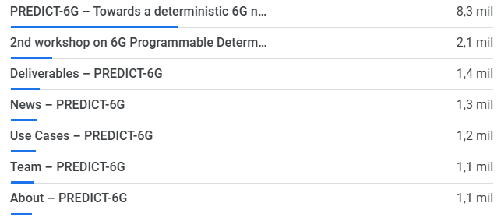
Figure 2. Top visited pages in PREDICT-6G website
On average, each visitor spends 0.53 minutes on the website. Overall, given the specific audience of a Research and Innovation Action (RIA) such as PREDICT-6G, the figures are positive, and the website has notably increased its traffic over time. In addition to the regular updates, new features and sections have been added as the project evolve, for instance, standardisation, demos, or the Special Session organized at EuCNC 2025.

Social media
PREDICT-6G social media are the pillar of the project daily communication. Active in LinkedIn, X (former Twitter) and BlueSky, the project social media community has reached 1,929 followers. Out those followers 1,043 come from X, 782 from LinkedIn and 104 from BlueSky, see Figure 2.

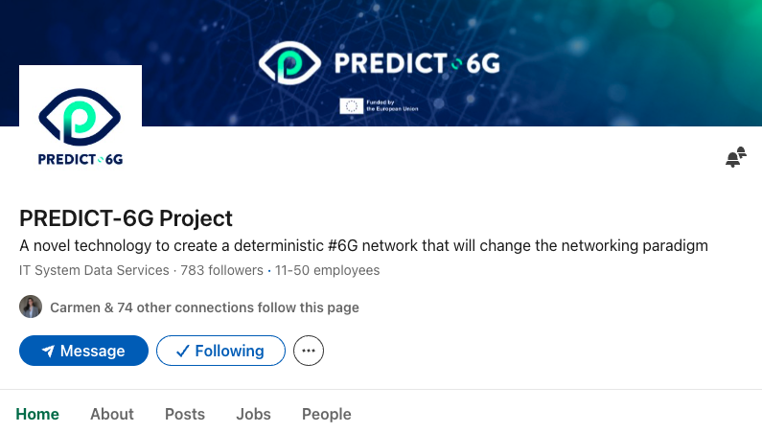
Figure 3. PREDICT-6G profile in LinkedIn
The main social media channels, X and LinkedIn, averaged 5,671 impressions per month. The total number of impressions is 169.217, with 68% coming from LinkedIn and 32% from X.
In November 2024, the project decided to open a Bluesky account to test the new platform and expand its reach to new audiences, after analyzing the controversies surrounding X and seeing that followers on that social media platform were decreasing considerably. However, while Bluesky initially looked promising, its growth rate slowed down relatively quickly, and in just over half a year, the project has only gained 104 followers. The platform does not provide additional data, such as impressions and engagement.
In Year 2 and 3, PREDICT-6G launched several social media campaigns to promote its outcomes, such as published scientific publications, public deliverables and demonstrations, Figure 4.

Figure 4. PREDICT-6G campaign to promote its outcomes
In addition, we launched awareness campaigns for specific events, such as “Women in Science” and 'Europe Day” (see Figure 4). and “International Women’s Day”, Figure 5.
Figure 5. "Women in Science" and “Europe Day” campaigns
In Year 3, two major campaigns were carried out. The first, one called “In the Spotlight”, focused on recognizing studies outside the project that were related to the PREDICT-6G theme, see Figure 6. The second one, called “PREDICT-6G Farewell”, aimed to bring the project to a close and give all the partners who had worked on it a voice, see Figure 6, Figure 7..
Figure 6. "In the spotlight” campaign

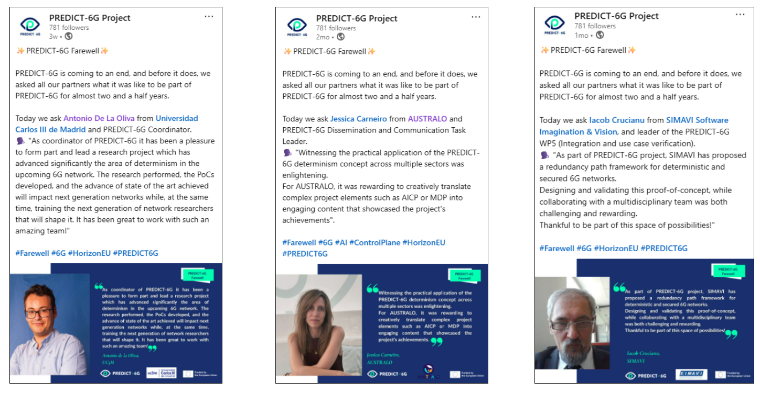
Figure 7. "PREDICT-6G Farewell” campaign
These campaigns, alongside day-to-day activity, have ensured that the work of PREDICT-6G during this period has reached its target audience. Most visitors work in senior positions in fields such as telecommunications, IT, network computation, academia and research, Figure 8. Spain, Belgium, Italy, the United Kingdom and Greece are the top visiting countries.
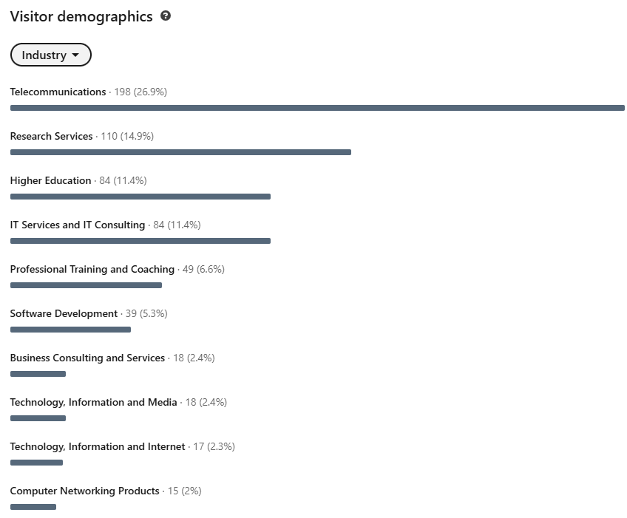
Figure 8. LinkedIn visitors’ demographics

Online repository: ZENODO
PREDICT-6G is committed to the Open Science principles, including Open Access. By providing access to the produced research outcomes, PREDICT-6G helps other projects and initiatives, and more broadly both the research and the industrial ecosystems, build upon them, encouraging collaboration, preventing duplication and overall enhancing the quality of research. Furthermore, open access facilitates the involvement of society and citizens in science, promoting transparency in the scientific process.
For this purpose, PREDICT-6G created an online repository in ZENODO. As of June 2025, the repository has 110 entries, including project deliverables and newsletters, scientific articles and conference papers, presentations, and promotional materials. The publications have 13,693 unique views and 13,986 downloads, almost reaching 30,000 interactions.
The most viewed publications were “PREDICT-6G Joint Press Release” and deliverables D1.1 “Analysis of use cases and system requirements” and D3.1 “Release 1 of AI-driven inter-domain network control, management, and orchestration innovations”.
The full list of publications can be found in Appendix 3: List of publications in Zenodo

Online articles, newsletters and press releases
During Year 2 and 3, PREDICT-6G published 57 online articles and 6 newsletters.

Online articles
PREDICT-6G published 57 online articles since January 2024. These tackle a variety of topics in relation to the project, from accounts of the plenary meetings to scientific pieces of information written by project members.
Some selected articles are listed below, from the oldest to the most recent publication:
- PREDICT-6G demonstration at the Mobile World Congress (MWC) Barcelona 2024.
- Deterministic services for critical communications.
- PREDICT-6G on Standards Requirements.
- PREDICT-6G contributes to 6G standardisation.
- PREDICT-6G celebrates the Citizen Science Month.
- 6G Programmable Deterministic Webinar Series: #1 Architectural enhancements for 6G programmable and deterministic networks.
- 2024 EuCNC & 6G Summit.
- PREDICT-6G’s PhDs: at the crossroads of industry and academia.
- PREDICT-6G – Advancing Network Determinism and Time-Sensitive Communication.
- MobiCom 2024: 2nd workshop on ‘6G Programmable Deterministic Networking with AI’.
- Integration Week at 5Tonic Open Lab.
- PREDICT-6G at EuCNC & 6G Summit 2025.
Those articles have been published in the PREDICT-6G website. Most were also published as part of the newsletters.
A list of all the articles can be found in Appendix 2: List of online articles.

Newsletters
PREDICT-6G newsletters were published quarterly with the objective to share updates, news and developments about the project, see Figure 9. They are released via Brevo and, since June 2023 (M06), also via the PREDICT-6G LinkedIn page. The newsletters reached a total of 589 subscribers: 460 on LinkedIn and 129 on Brevo.
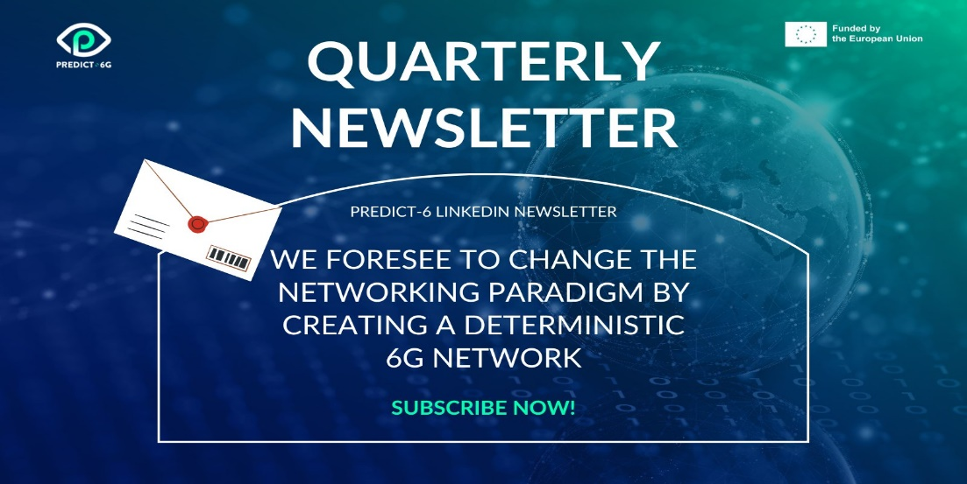
Figure 9. Visual promoting the PREDICT-6G newsletter.
PREDICT-6G released 10 newsletters, which have accumulated 1,264 views and 1,880 downloads in Zenodo. The opening rate is approximately 70%.
All the newsletters are available on the website and Zenodo, as detailed in Table 3.
Table 3. Newsletters
Newsletter | Date | Link
#1 Newsletter | 03.2023 | https://zenodo.org/records/7788016
#2 Newsletter | 06.2023 | https://zenodo.org/records/8119332
#3 Newsletter | 09.2023 | https://zenodo.org/records/8426303
#4 Newsletter | 12.2023 | https://zenodo.org/records/10518744
#5 Newsletter | 04.2024 | https://zenodo.org/records/10958725
#6 Newsletter | 06.2024 | https://zenodo.org/records/13379248
#7 Newsletter | 10.2024 | https://zenodo.org/records/13940369
#8 Newsletter | 12.2024 | https://zenodo.org/records/14531299
#9 Newsletter | 03.2025 | https://zenodo.org/records/15680519
#10 Newsletter | 06.2025 | https://zenodo.org/records/15720629
PREDICT-6G contributed to a total of 20 external publications in 2024 and 2025, mainly the SNS newsletter and newsflash, and the AUSTRALO newsletter, as detailed in Table 4.
Table 4. Sample of publications about PREDICT-6G (January 2024 – June 2025)
Publication | Date | Link
PREDICT-6G demonstration at MWC Barcelona 2024 | 2024.03 | https://www.linkedin.com/pulse/latest-australo-newsletter-out-australoteam-aenuf/?trackingId=2iRLrnwLSf6D9Dc8LHV8dg%3D%3D
PREDICT-6G “Target Wake Time” Demo | 2024.03 | https://smart-networks.europa.eu/sns-ju-march-2024-newsflash/
IEEE Wireless Communications and Networking Conference WCNC 2024, IAFA event series#4-2: second event on pre-standardisation – steps: 6G standardisation requirements, PREDICT-6G presentation at 6G IA Architecture WG Meeting & Demo Videos | 2024.04 | https://smart-networks.europa.eu/sns-ju-april-2024-newsflash/
Workshop 3 “The 6G series workshop by Hexa-X-II” with the participation of PREDICT-6G, The workshop 8 “Architectural Considerations Enabling the IMT 2030 Framework by European 6G R&D Activities”, The workshop 9 “Trials, Pilots and Demos for Selected Verticals: the Experimental Way Forward Towards 6G”, 6G Programmable Deterministic Webinar Series, SNS Stream B/D Projects Workshop on LPIs and KVIs | 2024.05 | https://smart-networks.europa.eu/sns-ju-may-2024-newsflash/
6G Programmable Deterministic Webinar Series: #1 Architectural enhancements for 6G programmable and deterministic networks | 2024.06 | https://www.linkedin.com/pulse/latest-australo-newsletter-out-australoteam-6zikf/?trackingId=CK2LYTWpSOuK6DBrrfcZTA%3D%3D
EuCNC & 6G summit 2024, IEEE ICC 2024, PREDICT-6G, DESIRE6G and DETERMINISTC6G call for papers and webinar series, PREDICT-6G participation in events | 2024.06 | https://smart-networks.europa.eu/sns-ju-june-2024-newsflash/
International Conference on Transparent Optical Network 2024, DESIRE6G and PREDICT-6G – call for papers for special issue of the IEEE Network Magazine, MOBICOM 2024 | 2024.07 | https://smart-networks.europa.eu/sns-ju-july-2024-newsflash/
Call for papers: MobiCom 2024 - Last chance! | 2024.08 | https://www.linkedin.com/pulse/follow-us-our-journey-through-leading-communication-those-twb6f/?trackingId=cGeo7pkNSIKTxTOa1Vpkig%3D%3D
IEEE PIMRC 2024, PREDICT-6G at IEEE ETFA 2024 | 2024.09 | https://smart-networks.europa.eu/sns-ju-september-2024-newsflash/
VTC2024 – Fall, 2nd webinar of 6G Programmable Deterministic Webinar Series, HEXA-X-II 6G Architecture and Standards workshop | 2024.10 | https://smart-networks.europa.eu/sns-ju-october-2024-newsflash/
HEXA-X-II organized a joint workshop on architecture and standards including presentations from pREDICT-6G | 2024.10 | https://smart-networks.europa.eu/sns-ju-october-2024-newsletter/
MOBICOM 2024 | 2024.11 | https://smart-networks.europa.eu/sns-ju-november-2024-newsflash/
PREDICT-6G Project co-organized the 2nd workshop on ‘6G Programmable Deterministic Networking with AI’ at MobiCom 2024 | 2024.12 | https://www.linkedin.com/pulse/follow-us-our-journey-through-leading-communication-european-pomfe/?trackingId=8MW9fbEhSPmvV%2FhE622Hng%3D%3D
IEEE GLOBECOM 2024, PREDICT-6G at “Más allá del horizonte” conference | 2024.12 | https://smart-networks.europa.eu/sns-ju-december-2024-newsflash/
PREDICT-6G plenary meeting & integration week in Madrid | 2025.01 | https://smart-networks.europa.eu/sns-ju-january-2025-newsflash/
PREDICT-6G first plenary meeting of 2025 | 2025.02 | https://www.linkedin.com/pulse/follow-us-our-journey-through-leading-communication-european-myxhf/?trackingId=4zmVpyXhShe%2FFii74YsQ6Q%3D%3D
SNS project contributions at EuCNC & 6G Summit 2025, AI & Security webinar | 2025.04 | https://smart-networks.europa.eu/sns-ju-april-2025-newsflash/
SNS project contributions at EuCNC & 6G Summit 2025: Network Digital Twins & AI Orchestration, and workshop 3, SNS projects at ICT 2025, 6G Programmable Deterministic Webinar series #3 | 2025.05 | https://smart-networks.europa.eu/sns-ju-may-2025-newsflash/
PREDICT-6G Project Webinar: Challenges for Deterministic & Programmable 6G Networks | 2025.05 | https://www.linkedin.com/pulse/check-out-latest-opportunities-industry-50-deep-tech-projects-is5tf/?trackingId=OtlnV%2ByPrf2CdrPzSI0v2Q%3D%3D
EuCNC: PREDICT-6G Project | 2025.06 | https://www.linkedin.com/pulse/check-out-latest-opportunities-industry-50-deep-tech-projects-jbbbf
Furthermore, PREDICT-6G has contributed to the SNS Journal 2024 and the SNS Journal 2025.

Dissemination activities in Year 2 and 3
The main goal of a dissemination plan is to make the project scientific and technological results available to the project stakeholders. To this end, PREDICT-6G put in place a comprehensive dissemination plan, incorporating a set of activities that would enable to effectively accomplish the objectives defined, namely: to build and grow a community around the project; to gain visibility and promote the work and results among target stakeholders; to disseminate the project and its outcomes to the largest community; to encourage external participation and knowledge sharing; and, to liaise with other EU, national and international initiatives.
During the last 18 months, PREDICT-6G leveraged the general awareness created during Phase I and Phase II of the plan. The maturity of the project made available concrete outcomes that were presented through dedicated activities, including journals, conferences and white papers, among others. PREDICT-6G also prioritized strengthening the relationship with target stakeholders while attracting new potential users, costumers, and adopters of the project outcomes. The synergies with exploitation and standardisation activities have been of great importance for reaching the set project KPIs.

Scientific Publications and Conferences
Between January 2024 and June 2025, PREDICT-6G produced a total of 28 scientific papers. Of those, 5 were published in prestigious journals and 23 were accepted in flagship conferences. In total, PREDICT-6G has published 10 papers in journals and 37 conference papers during its duration.

Scientific Journals
Since January 2024, PREDICT-6G has published 5 papers in prestigious journals:
- F. Mungari, C. Puligheddu, A. Garcia-Saavedra and C. F. Chiasserini, "O-RAN Intelligence Orchestration Framework for Quality-Driven Xapp Deployment and Sharing," in IEEE Transactions on Mobile Computing, doi: 10.1109/TMC.2025.3527707
- L. Velasco, G. Graziadei, S. Barzegar and M. Ruiz, "Provisioning of Time-Sensitive and Non-Time-Sensitive Flows with Assured Performance," in IEEE Transactions on Network and Service Management, vol. 22, no. 2, pp. 1484-1499, April 2025, doi: 10.1109/TNSM.2025.3539697
- A. Calvillo-Fernandez, T. Dimitrovski, M. Groshev, A. Ganesh, C. Ayimba and A. de la Oliva, "Attention to Virtualization: Making Network Digital Twins Aware of Network Slicing" in IEEE Network, vol. 39, no. 3, pp. 134-139, May 2025, doi: 10.1109/MNET.2025.3552137
- R. Rosales and D. Calvalcanti, “Reinforcement learning, rule-based, or generative AI: a comparison of model-free Wi-Fi slicing approaches” in Frontiers in Signal Processing, vol. 5, 26 May 2025, https://doi.org/10.3389/frsip.2025.1608347
- Pagès, Albert & Guasch, Enric & Agraz, Fernando & Spadaro, Salvatore. (2025). KPI-aware Service Provisioning for Remote Industrial Control Systems Management. Computer Communications. 238. 108191. 10.1016/j.comcom.2025.108191.
- D. Rico-Menendez et al., "Experimentation on A Wireless Multi-Domain Deterministic Network: The SLICES-Madrid Approach" in IEEE Communications Magazine, vol. 63, no. 2, pp. 54-60, February 2025, doi: 10.1109/MCOM.001.2400320
In total, PREDICT-6G has published 10 papers in prominent journals. These accumulate 284 citations in Google Scholar. All journal publications are listed in Appendix 1: Scientific publications in journals.
Moreover, UPC, has submitted a paper to the IEEE Transactions on Industrial Informatics journal titled “Uplink and Downlink Slice-aware OFDMA Resource Allocation for Smart Factory Networks”. Due to the ongoing review process, no additional information can be provided at this point.

Scientific Conferences, Workshops, and Panels
Since January 2024 until September 2025, PREDICT-6G will have attended 20 conferences across Europe, Canada, Dubai, Japan, South Africa and the United States. Many of these constituted the second and even third participation of the project in said events, showing its consistent efforts to disseminate its results among the scientific community.
A total of 31 papers were accepted in those conferences. Moreover, PREDICT-6G (co)organized 8 workshops and 4 industrial panels. The participation of PREDICT-6G is reported in articles published in newsletters, the website “Scientific Publications” page and its social media channels.
20th IEEE International Conference on Factory Communications Systems (WCFS) 2024, 17-19 April 2024, Toulouse, France.
INTEL represented PREDICT-6G for the second consecutive year in the WCFS 2024. The consortium partner presented two papers: "A Software Platform for Testing Multi-Link Operation in Industrial Wi-Fi Networks" and "Wireless Network Digital Twin Calibrated by Real Time Telemetry and XR Feedback Interface", in the Wi-Fi in Industrial Communication session.
Link: https://wfcs24.inviteo.fr/
IEEE Wireless Communications and Networking Conference (WCNC) 2024, 21-24 April 2024, Dubai, United Arab Emirates.
Valerio Frascolla (INTEL) was invited as a panelist in the “6G: Midway Status and Way Forward” workshop. He also delivered the Invited Talk “Predictable Networks and TSN: Benefit on the Manufacturing Vertical Sector” at the industry Talk Session #2, where he briefly described the PREDICT-6G proposed AI-driven Multi-stakeholder Inter-domain Control-Plane (AICP), and Multi-technology multi-domain Data-Plane (MDP).
PREDICT-6G also presented two papers in the “6GARCH: the 3rd workshop on 6G Architecture”: "6G Architecture for Enabling Predictable, Reliable and Deterministic Networks: the PREDICT-6G Case" (David Rico, UC3M) and "Formation and Assertion of Data Unit Groups in 3GPP Networks with TSN and PDU Set Support" (Sebastian Robitzsch, IDE).
Link: https://wcnc2024.ieee-wcnc.org/
IEEE International Conference on Computer Communications (INFOCOM 2024), 20-23 May 2024, Vancouver, Canada
POLITO presented two papers: "OREO: O-RAN intElligence Orchestration of xApp-based network services" in the Session B-1: Radio Access Networks and "Resource-aware Deployment of Dynamic DNNs over Multi-tiered Interconnected Systems" in the Machine Learning 2 session.
Link: https://infocom2024.ieee-infocom.org/
IEEE International Instrumentation and Measurement Technology Conference (I2MTC), 20-23 May 2024, Glasgow, United Kingdom
CNR presented the paper “A TSN-based Technique for Latency Measurement in Real-Time Wireless Communication networks" in the Poster Session.
Link: https://i2mtc2024.ieee-ims.org/

EuCNC & 6G Summit 2024, Antwerp, Belgium
During its second participation in EuCNC, PREDICT-6G had a joint booth with DESIRE6G: “Programmable deterministic networking: the PREDICT-6G and DESIRE6G approaches”, see Figure 10.

Figure 10. Booth background designed by AUS
In addition to the “Experimentation in a wireless multi-domain deterministic network” poster by UC3M and Intel, the booth hosted various demos: “Target Wake Time” by POLITO, “Smart Factory” by Gestamp and Ericsson, “Monitoring Data Collection Integration with a Sensing-Enabled 3GPP Technology Domain’‘ by Nextworks and InterDigital, and “Real-time Gesture Based Remote Control of a Digital Twin” (UC3M).
PREDICT-6G also participated in three workshops. Prof. Antonio de la Oliva (UC3M), PREDICT-6G coordinator, delivered a presentation in the “The 6G series workshop by Hexa-X-II” with a presentation titled “The importance of determinism in 6G networks”. Dr. Sebastian Robisch (InterDigital), chair of PREDICT-6G Standardisation Advisory Board, moderated the “Architectural Considerations Enabling the IMT 2030 Framework by European 6G R&D Activities” workshop. Finally, Valerio Frascolla (INTEL), PREDICT-6G innovation manager, delivered a presentation in the “Trials, Pilots and Demos for Selected Verticals: The Experimental Way Forward towards 6G” workshop.
The PREDICT-6G communication efforts during the EuCNC & 6G Summit, led by AUSTRALO, were recognized with the “Best Social Media Presence Award”.
Link: https://www.eucnc.eu/
IEEE International Conference on Communications (ICC) 2024 "Scaling the Peaks of Global Communications", 9-13 June 2024, Denver, United States of America
POLITO presented the paper "Generosity Pays Off: A Game-Theoretic Study of Cooperation in Decentralized Learning" as part of the Edge Learning over 5G Mobile Networks and Beyond (EDGE5GMN) workshop.
Link: https://icc2024.ieee-icc.org/
IEEE International Mediterranean Conference on Communications and Networking (MeditCom), 8–11 July 2024, Madrid, Spain
Ericsson presented the paper “Smart De-jittering using Network Digital Twin” in the main track SO1: Machine Learning for Communications 1.
Link: https://meditcom2024.ieee-meditcom.org/
24th International Conference on Transparent Optical Networks (ICTON) 2024, 14-18 July 2024, Bari, Italy
UPC organized the 6G Network Operation (6GNeO) workshop, with a special session on Time Sensitive Networking (TSN) and Deterministic Networking (DetNet). During this session, TID presented the paper ‘Reliability in deterministic networks: Comparison of FRER (TSN) and PREOF (DetNet)’, which was developed in the framework of PREDICT-6G, see Figure 11. UPC and TID team at ICTON 2024
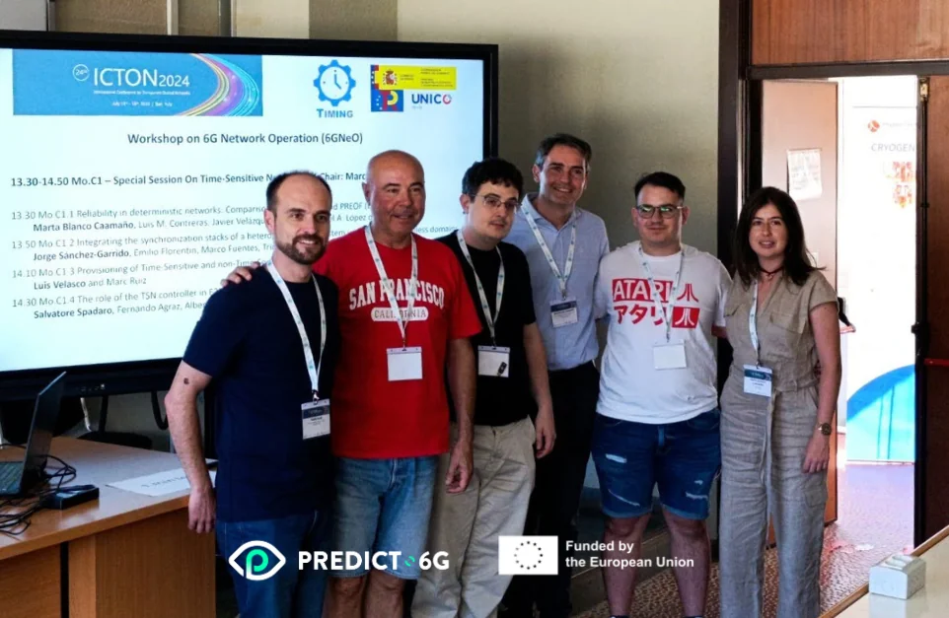
Figure 11. UPC and TID team at ICTON 2024
Link: https://icton2024.fbk.eu/home
IEEE International Symposium on Personal, Indoor and Mobile Radio Communications (PIMRC) 2024, 2-5 September 2024, Valencia, Spain
Two PREDICT-6G partners – UPC and POLITO – attended PIMRC 2024. UPC presented the paper ‘Novel Radio Frame Design for Efficient Integration of Wireless Links into Time-Sensitive Networks’ as part of the workshop on Industrial Wireless Network, whilst POLITO presented the paper “Target Wake Time Scheduling for Time-Sensitive Networking in the Industrial IoT” in T2-S2: Track 2- Session 2: IoT Networks.
Link: https://pimrc2024.ieee-pimrc.org/
IEEE International Conference on Emerging Technologies and Factory Automation (EFTA) 2024, 10-13 September 2024, Padova, Italy
PREDICT-6G presented the papers "Time-Sensitive Networking and Software-Defined Networking: an experimental setup for realistic performances" in the TSN in Industrial Systems session; “IEEE 1588 (PTP) over mmWave 5G NR: preliminary assessment of the synchronization accuracy for TSN applications” in WIP2 - Industrial Communication Technologies and Systems, and “Time-Sensitive Networking for Trajectory Tracking of an Unmanned Ground Vehicle over Wi-Fi” in the special session - Exploring the limits of Time Sensitive Networking, see Figure 12.
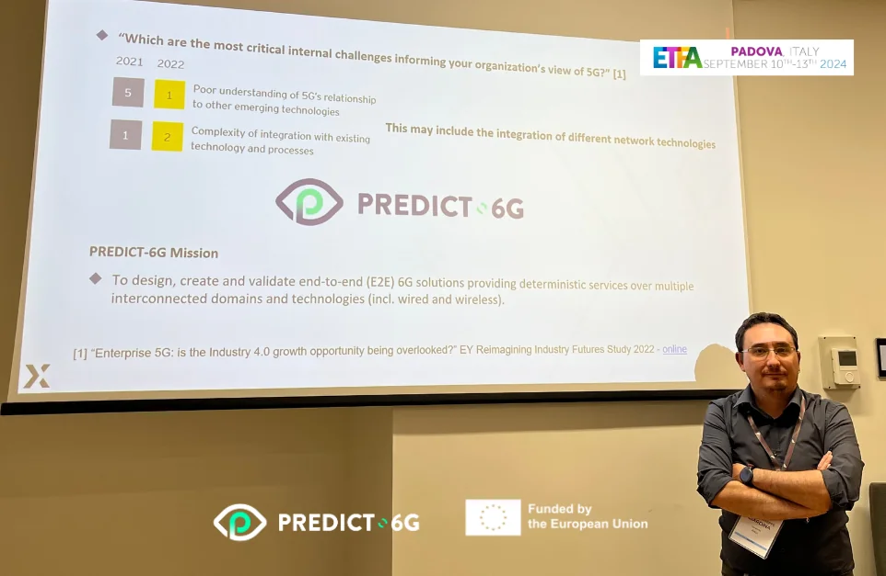
Figure 12. Pietro Giardina (Nextworks) at EFTA 2024
Link: https://2024.ieee-etfa.org/
2024 IEEE 100th Vehicular Technology Conference (VTC2024-Fall), 7-11 October 2024, Washington DC, USA
UPC attended the VTC2024-Fall 2024. It presented two papers “Reinforcement Learning-based UL/DL Splitter for Latency Reduction in Wireless TSN Networks” in a session about recent results and “Slice-aware Resource Allocation and Admission Control for Smart Factory Wireless Networks” in the Heterogeneous Networks session.
Link: https://events.vtsociety.org/vtc2024-fall/
2024 IEEE 49th Conference on Local Computer Networks (2024 LCN) , 8-10 October 2024, Normandy, France
POLITO and UC3M attended LCN 2024, where the paper "Data-Driven and Privacy-Preserving Cooperation in Decentralized Learning” was presented.
Link: https://www.ieeelcn.org/prior/LCN49/index.html
Mobicom 2024, 18-22 November 2024, Washington DC, USA
PREDICT-6G, DESIRE6G and DETERMINISTIC6G participated in the conference as co-organizers of the 2nd Workshop on “6G Programmable Deterministic Networking with AI” (6G-PDN 2).
The objective of this workshop was to discuss the roadmap and challenges in the technology areas of deterministic communications and deep network programmability in 6G to support future end-to-end time-critical applications.
Amir Gomroki, Head of 5G for North America and 5G Alliance for Connected Industries and Automation (5G-ACIA) Ambassador for Ericsson Research, and Ashutosh Dutta, Senior Scientist, 5G Chief Strategist at Johns Hopkins University Applied Physics Laboratory and Director of the Doctor of Engineering Programme at Johns Hopkins University delivered the keynotes.
As a result of an open call for papers, the selected authors discussed in depth various aspects of deterministic networks:
- Experimental Evaluation of a Multi-Domain TSN Scenario in Industry 4.0, first author: David Rico-Menéndez (University Carlos III Madrid).
- Routing-Aware Shaping for Feasible Multi-Domain Determinism, first author: Andrea Francini (Nokia Bell Labs).
- Environmental-aware Reinforcement Learning-based Scheduler for Trustworthy 6G in the Factory Floor, first author: Fjolla Ademaj-Berisha (Silicon Austria Labs GmbH).
- Lightweight INT on the Tofino programmable switch, first author: Angelos Dimoglis (University of Amsterdam).
- An Architectural Framework for 6G Network Digital Twin, first author: Zhiheng Yang (University of Amsterdam).
- Artificial Intelligence Control Plane for Deterministic Networks Proof-of-Concept, first author: Alejandro Calvillo-Fernandez (University Carlos III Madrid).
Link: www.sigmobile.org/mobicom/2024/
IEEE GLOBECOM 2024, 8-12 December 2024, Cape Town, South Africa
Led by Sebastian Robitzsch, PREDICT-6G standardisation coordinator, the project presented the paper ‘Standardisation Assessment of a Digital Twin-Based Multi-Domain Deterministic Communications System’ during the 6GArch: Workshop on 6G Architecture.
Link: https://globecom2024.ieee-globecom.org/
The 31st IEEE International Conference on Telecommunications (ICT 2025), 18-19 April 2025, Budva, Montenegro
Valerio Frascolla, Director of Research and Innovation at Intel and PREDICT-6G Impact Creation Leader, represented the project at ICT 2025. He organized and moderated panel 'Determinism and predictability in multi-domain networks for Industrial IoT and Smart cities', together with the EU-funded projects MultiX and 6G-SENSES. Valerio also delivered the keynote 'Mixed criticality networks in the Industrial Internet of Things' and presented the paper 'Dynamic spectrum management in multi-access systems towards 6G'. Figure 13 shows the Keynote and the Panel giving credits via the shown logos to the PREDICT-6G project (together with MultiX and 6G-SENSES).
Link: https://ict2025montenegro.ucg.ac.me/

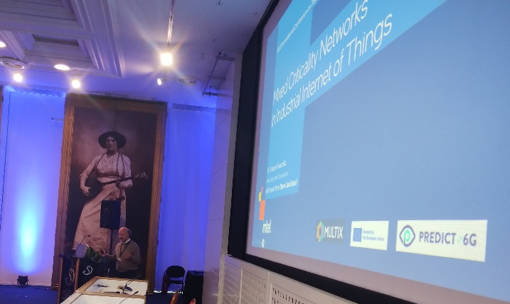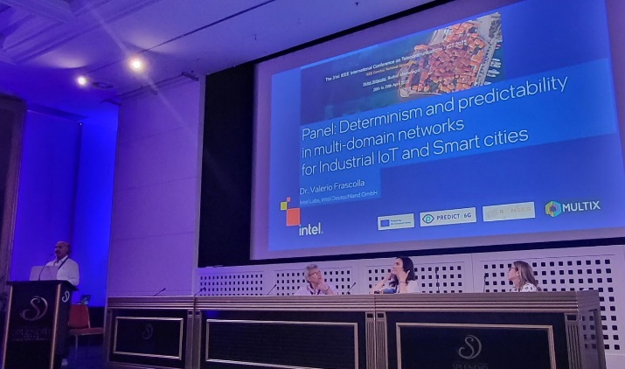
Figure 13. Left: Valerio giving the keynote. Left: Valerio introducing the Panel.
EuCNC & 6G Summit 2025 “Towards the 6G World”, 3-6 June 2025, Poznan, Poland
During EuCNC 2025, PREDICT-6G, in collaboration with DESIRE6G and MultiX, set up the joint booth: “Unfolding 6G’, which hosted various demos, see Figure 14.
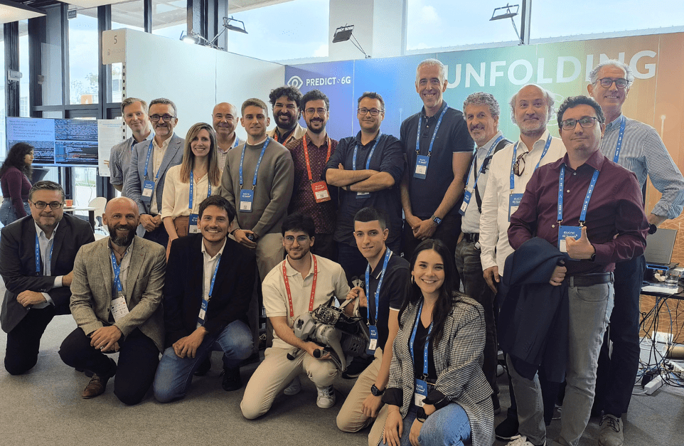
Figure 14. Many PREDICT-6G partners in front of the EUCNC 2025 booth (source AUSTRALO)
On the 5 of June 2025, PREDICT-6G held its fine event: a special session on PREDICT-6G’s main results and highlights. Attended by approximately 70 participants, the event marked the end of two and a half years of intensive research, development and collaboration within the Horizon Europe SNS JU.
Antonio de la Oliva (UC3M), project coordinator, and Odysseas Pyrovolakis, PREDICT-6G’s project officer, welcomed the participants and emphasized the importance of the SNS JU in promoting European leadership in 6G technologies. This was followed by an in-depth overview of the main achievements of the project presented by Zoltán Vincze (Nokia). Luis Miguel Contreras Murillo (TID) then offered architectural and business perspectives, providing a strategic view of the project’s long-term impact and relevance.
Marc Mollà Roselló (Ericsson) and Pietro Giardina (Nextworks) provided technical insights, delving into key innovations in the data plane, AI-driven control plane, and network digital twin (NDT) concepts. The session also included live demonstrations of selected technologies developed within the project, showcasing their readiness for use in the real world.
The final event concluded with a panel discussion on the future of dependable networking, moderated by Valerio Frascolla (Intel), PREDICT-6G Impact Creation Leader. The panel featured expert contributions from Chrysa Papagianni (DESIRE6G), Associate Professor at the Informatics Institute – University of Amsterdam; Joachim Sachs (DETERMINISTIC6G), Senior Expert at Ericsson; Josep Vidal (5GSmartFact), Full Professor at the Universitat Politècnica de Catalunya; and Zoltán Vincze (PREDICT-6G), Senior Research Engineer at Nokia Bell Labs. The discussion touched on cross-project synergies, future research directions, and policy challenges ahead. Approximately 80 participants joined the event.
PREDICT-6G also participated in the Workshop 3 “Integrating Network Digital Twinning into Future AI-based 6G Systems”, where Claudio Casetti delivered the presentation “WiFI Digital Twins for Time Sensitive Networking”. As part of the session NET2 - Network management, and Applications, Sebastian Robitzsch (IDE) presented the paper 'Data Unit Groups Implementation and Validation for Multi-Domain and Multi-Technology Deterministic 6G Systems”
Link: www.eucnc.eu
The 21st International IEEE Conference on Factory Communication Systems (WFCS 2025), 10-13 June 2025, Rostock, Germany
On the 13th of June 2025, Valerio Frascolla chaired the Industry Forum of WFCS, where he also moderated the industrial Panel. The Panel was co-organized in synergy with the EU-funded projects MultiX and DETERMINISTIC6G, as shown in Figure 15, where one can see PREDICT-6G, MultiX and DETERMINISTIC6G logos in the project slide in the background.
Link: https://wfcs25.uni-rostock.de/
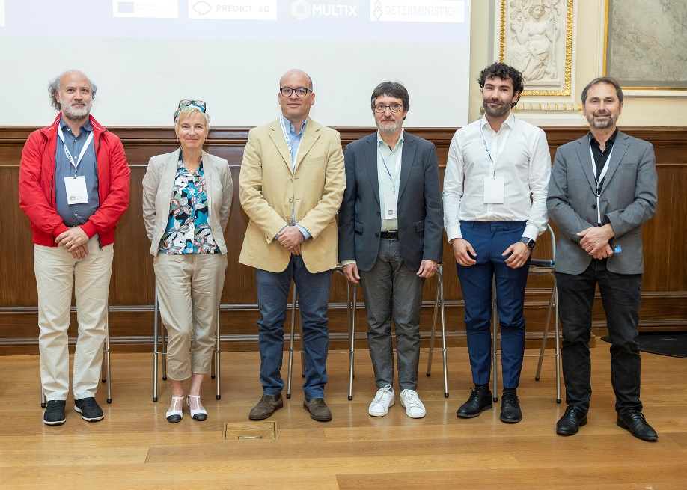
Figure 15. Valerio Frascolla (first left) and the other panelists of the Industry Forum.
30th OptoElectronics and Communications Conference (OECC 2025), 29 June – 3 July 2025, Sapporo, Japan
UPC will present the paper “KPI Assurance in Deterministic Optically Interconnected Cloud/Edge Infrastructures” in the session " Optical Networks for Computing”. It will also co-organise the workshop “Can SDM Survive the Hollow Core Challenge?”, which will explore the evolving landscape of high-capacity optical communications, focusing on the impact of hollow core fibers (HCF) on the future viability of Spatial Division Multiplexing (SDM
Link: www.oeccpsc2025.org
25th International Conference on Transparent Optical Networks (ICTON 2025), 6-10 July 2025, Barcelona, Spain
UPC will host ICTON 2025. The PREDICT-6G partner will present two papers: “On the selection of KPI-aware E2E paths for deterministic services in 6G Networks” in the Systems session and “Demonstration of a Control Plane in Support of E2E Deterministic Service Provisioning over a Multi-domain Multi-technology 6G Network” in the Demos and Posters session.
11th 2025 International Conference on Control, Decision and Information Technologies (CoDIT 2025), 15-18 July 2025, Split, Croatia
PREDICT-6G will attend CoDIT 2025 for the first time, where UC3M will present the paper “Towards Goal-Oriented Semantic Orchestration for Resource-Aware Robotic Function Offloading”.
Link: https://codit2025.org/
Internet Engineering Task Force (IETF) 123 Hackathon, 19-20 July 2025, Madrid, Spain
The IETF will hold a hackathon to encourage developers and subject matter experts to discuss, collaborate, and develop utilities, ideas, sample code, and solutions that show practical implementations of IETF standards. The event is jointly organized by DESIRE6G and PREDICT-6G.
Link: https://wiki.ietf.org/en/meeting/123/hackathon#deterministic-networking
30th IEEE International Conference on Emerging Technologies and Factory Automation (EFTA) 2025, 9-12 September 2025, Porto, Portugal
CNR, UNIPD and INTEL will present two papers "Comparative Performance Analysis of Artificial Intelligence- and Distance-Based Wi-Fi Handovers" and "Wireless Time-Sensitive Networking for Real-Time Unmanned Ground Vehicle Control and Mapping".
Link: https://etfa2025.ieee-ies.org/

Technical publications
PREDICT-6G and its partners co-authored the white papers below:
- “Towards 6G architecture: Key concepts, challenges, and building blocks”, May 2025, SNS JU 6G Architecture WG.
Gramaglia, M., Bulakci, Ö., Li, X., Gavras, A., Ericson, M., Kerboeuf, S., Larrabeiti, D., Ghoraishi, M., Mesodiakaki, A., Koumaras, H., Robitzsch, S., Asensio Garriga, R., Skarmeta Gómez, A., & Tsolkas, D. (2025). Towards 6G Architecture: Key Concepts, Challenges, and Building Blocks. Zenodo. https://doi.org/10.5281/zenodo.15001378
- “6G KPIs - Definitions and Target Values”, January 2025, SNS JU Test, Measurement, and KPIs Validation (TMV) WG.
Mesogiti, I., Gavras, A., Trichias, K., Kaloxylos, A., Fontes, F., Charemis, A., Ghoraishi, M., Mollà Roselló, M., Yadranjee Aghdam, P., Agapiou, G., Sgambelluri, A., Al-Rawi, M., Marques, C., & Mohr, W. (2025). 6G KPIs - Definitions and Target Values. Zenodo. https://doi.org/10.5281/zenodo.15011631
- “European Vision for the 6G Network Ecosystem”, November 2024, 6G-IA Vision WG
Uusitalo, M., Bernardos, C. J., Kaloxylos, A., Bourse, D. A., Norp, T., Lønsethagen, H., Hecker, A., Rugeland, P., Papagianni, C., Bulakci, Ö., Li, X., Ericson, M., Anton-Haro, C., Massod Khorsandi, B., Ramos-Lopez, A., Frascolla, V., Marco, G., Gavras, A., & Trichias, K. (2024). European Vision for the 6G Network Ecosystem. Zenodo. https://doi.org/10.5281/zenodo.14230482.

Events, conferences and workshops (non-peer reviewed)
In the last 18 months, PREDICT-6G participated in many scientific (non-peer reviewed) events to present the project, its objectives, activities and results. These events contributed to raise awareness about the vision and work of the project among key stakeholders with specific expertise and interest in the area.
Many of the events brought different parts of the scientific community together allowing for a cross-fertilization of ideas benefited PREDICT-6G greatly. The involvement of the industry has also contributed to validate the interest of the market in the scientific outputs and to guide their future exploitation. Moreover, the presence of policymakers has helped PREDICT-6G, and the importance of 6G technologies, gain a lot of exposure. PREDICT-6G was also involved in various awareness events that introduced the project to a wide audience, including local and national authorities, students, and similar initiatives.
The presence of PREDICT-6G in these events contributed to bring research closer to the citizens and helped to bridge the gap between innovation and market as well as to incentivize the private funding. Moreover, these efforts are also expected to bring policymakers at various levels onboard with the development of 6G technologies and their standardisation.
Table 5 compiles all the non-peer reviewed events, conferences and workshops.
Table 5. Awareness and non-peer reviewed events
Event | Date | Place | Activity
Mobile World Congress 2024 | 26-29 February 2024 | Barcelona, Spain | IDE presented the demo “Novel User Plane concepts for deterministic communications in an ISAC setting” at the company space “At Work: Sensing-Enabled 6G Mobile Networks”.  Link: https://predict-6g.eu/2024/02/29/predict-6g-demonstration-at-mwc-barcelona-2024/
IAFA Event Series #4-2: Second event on pre-Standardisation – Steps: 6G Standardisation Requirements | 9 April 2024 | Online | Presentation “Extensions to wireless DetNet” by Carlos J. Bernardos.  Link: https://zenodo.org/records/10984472
SNS Stream B/D Projects Workshop on KPIs and KVIs | 16 May 2024 | Online | Workshop organized by the SNS TB. Presentation by Marc Molla (Ericsson)  Link: https://zenodo.org/records/11204356
6G Programmable Deterministic Webinar Series: #1 'Architectural enhancements for 6G programmable and deterministic networks' | 14 June 2024 | Online | Presentation “Multi-domain Deterministic Service Management Architecture” by Peter Szilagyi (Nokia)  Link: https://zenodo.org/records/12204866, https://youtu.be/IufPDoU9oUg?feature=shared
IEEE International Conference on High Performance Switching and Routing (HPSR) 2024 | 22–24 July 2024 | Pisa, Italy | Nextworks had a booth featuring PREDICT-6G, including a poster “Towards a deterministic 6G network: reliable, time sensitive and predictable”  Link: https://zenodo.org/records/15656405
Hexa-X-II standardisation workshop. | 17 October 2024 | Online | Presentation by Sebastian Robitzsch (IDE) "Standardisation Assessment of a Digital Twin-Based Multi-Domain Deterministic Communications System" in the Session 1 – System Architecture.  Link: https://hexa-x-ii.eu/the-6g-series-workshop-by-hexa-x-ii/
6G Programmable Deterministic Webinar Series: #2 ‘Wireless-friendly TSN scheduling’ | 22 October 2024 | Online | Presentation “Wireless-aware TSN configuration and management” by Dave Cavalcanti (INTEL)  Link: https://zenodo.org/records/13990246, https://youtu.be/VEJAmQT4XU0?feature=shared
5G Techritory Forum | 30-31 October 2024 | Riga, Latvia | PREDICT-6G shared the live demonstration ‘Real time gesture-based remote control of a digital twin”, in a joint video with other SNS projects.  Link demo: https://www.youtube.com/watch?v=H_I3xAcHm2E
InfoCom World 2024 | 12 November 2024 | Athens, Greece | PREDICT-6G showcased a VR demonstration powered by next-generation 6G technology during the event.
6G+ Chips Workshop | 20 November 2024 | Online | Organised by COGNINN, it gathered several SNS projects. Presentation by Antonio de la Oliva (UC3M) “Multi-domain, multi-technology deterministic data plane: the PREDICT-6G approach”  Link: https://zenodo.org/records/14259645
12th Conference of the European Union Framework Programme for Research and Innovation in Spain, Horizon Europe: “Más allá del Horizonte” | 28 November 2024 | Oviedo, Spain | PREDICT-6G participated with a poster.  Link: https://zenodo.org/records/15656405
Mobile World Congress 2025 | 3-6 March 2025 | Barcelona, Spain | IDE presented the demo “Novel User Plane concepts for deterministic communications in an ISAC setting” developed in PREDICT-6G in its space “At Work: Sensing-Enabled 6G Mobile Networks”  Link: https://predict-6g.eu/2024/02/29/predict-6g-demonstration-at-mwc-barcelona-2024/
"AI and Security Webinar" | 30 April 2025 | Online | COGNINN delivered the presentation “Threats and Security Enablers for Predictive 6G Networks”.  Link: https://zenodo.org/records/15222163
6G Programmable Deterministic Webinar Series: #3 'Next challenges in 6G for programmable and deterministic networks' | 20 May 2025 | Online | PREDICT-6g co-organized and moderated the workshop.  Link: https://zenodo.org/records/15547999, www.youtube.com/watch?v=-Ip7uLqfmoo
Digital Innovation at Horizon Europe Cluster 4 Info Day | May 2025 | Online | David Rico (UC3M) gave the presentation “Multi-Domain TSN for Industry 5.0” and presented the demo “Real Time Gesture-based remote control of a digital twin”.  Link: https://predict-6g.eu/2025/05/23/predict-6g-presents-a-demo-at-the-horizon-europe-cluster-4-info-day/
Foro de Innovación y Tecnología (Forum of Innovation and Technology), 17 June 2025, Guipuzcua, Spain | 17 June 2025 | Gipuzkoa, Spain | Manuel Lorenzo, Head of Technology and Innovation in Ericsson Spain and member of the PMC of PREDICT-6G, was invited to the Forum to share the insights and trends of 5G/6G evolving technologies as enablers of I4.0/ I5.0 scenarios  Concrete experiences and learnings in this subject from the series of projects carried out at 5TONIC lab for over 8 years were laid out, along with reflecting on the most influential trends on the evolution from 5G-I4.0 state-of the-art towards the upcoming 6G-I5.0 ecosystem, as identified at the 5G-PPP whitepaper “Innovation Trends in I4.0 enabled by 5G and Beyond Networks” coordinated by Manuel Lorenzo and counting on major contributions from PREDICT-6G.  Central subjects of research for PREDICT-6G, such as deterministic networking and digital twinning, were further discussed at the fruitful workshops held in the afternoon sessions devoted to identifying new collaboration, innovation and business opportunities.

PREDICT-6G Multimedia

Promotional material
Table 6 showcases the promotional materials envisioned as part of the Communication and Dissemination Strategy and a summary of their status in Years 2 and 3.
Table 6. Promotional materials hardcopies
Type of material | Number of copies | Event(s)
Leaflet (Trifold) | 300 | EuCNC 2024, ICC 2024, EuCNC 2025
Flyer (one page only) | 460 | EuCNC 2024, EuCNC 2025 MWC 2024, MWC 2025
Roll-up | 2 | EuCNC 2023 and EuCNC 2025
Poster | 2 | IEEE HPSR 2024  https://zenodo.org/records/15656405  EuCNC 2024 https://zenodo.org/records/11571640
Merchandise | 280 | EuCNC 2024 & EuCNC 2025
Booth Backgrounds | 2 | EuCNC 2024 & EuCNC 2025
Digital banners | >100 | Website news and social media posts
A total of 200 copies of the PREDICT-6G trifold were distributed at the 2024 and 2025 EUCnC & 6G Summits as well as the ICC 2024. They were made available at both the PREDICT-6G and SNS JU booths.
PREDICT-6G also created several flyers illustrating the project demos. Figure 16 shows the flyer for the demo “Novel User Plane concepts for deterministic communications in an ISAC setting” for the MWC.
Figure 16. Flyer for MWC (designed by AUS, content by IDE)
Figure 17 showcases a flyer indicating the different activities in which PREDICT-6G was involved during EuCNC 2024 whilst Figure 18 depicts a poster displayed in the project booth during that same event.
Figure 17. Left: Flyer for EuCNC 2024. Right: Back of the same flyer (designed by AUS)
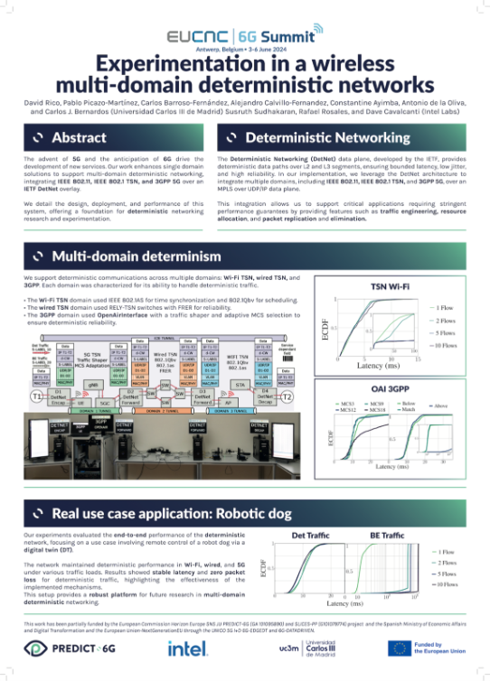
Figure 18: PREDICT-6G poster for EuCNC 2024
Some of the promotional materials have been showcased in different parts of Chapter 2. These can also be found in social media and other publications.

Videos
PREDICT-6G launched its YouTube channel in September 2023 as a complementary tool to the efforts to communicate and disseminate the progress being made in the different WPs, as well as to bring the people working on the project closer to the audience, see Figure 19.

Figure 19. PREDICT-6G YouTube channel
A total of 12 videos were uploaded during this period, accumulating 820 views and 37.2 hours of watch time. The videos have been organized into three playlists: 'Demos', 'Integration Week' and 'The 6G Programmable Deterministic Webinar Series'.
The ‘Demos’ playlist includes 5 videos, 4 of these are demos recorded by the partners in charge of each use case, while the fifth one is a live demo of the ‘Real-time gesture-based remote control of a digital twin’ use case, recorded during EuCNC 2024. This playlist was watched for a total of 7.6 hours.
The ‘Integration Week’ playlist includes 3 videos, all of which were recorded during Integration Week in Madrid in January 2025. This event took place alongside the Plenary Meeting. The aim of the playlist was to showcase the work of the partners responsible for integrating the PREDICT-6G network in a relaxed and personal way. Most of the views of these videos were generated directly through LinkedIn, the platform for which they were originally created.
Finally, the '6G Programmable Deterministic Webinar Series' playlist contains the recordings of 3 webinars organized in collaboration with the DESIRE6G and DETERMINISTIC6G projects. The total watching time of this playlist is 29 hours.
3 out of the 5 most-viewed videos of the channel are PREDICT-6G demonstration videos, see Figure 20.
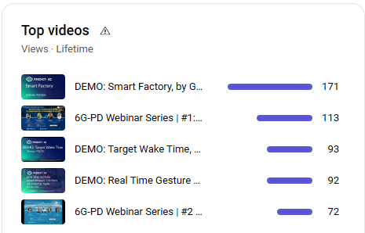
Figure 20. Top PREDICT-6G videos
In addition, a video summarizing the Final Event of the PREDICT-6G project, which was held during EuCNC 2025, will be added to the channel at the end of June. This is because the video has not yet been finalized at the time of writing this deliverable. The video will be used for the project's final communication and dissemination activity across all social media channels.

Ecosystem building and stakeholder management
PREDICT-6G stakeholder management strategy is based on an agile framework. It follows an iterative structure that allows to steadily increase and reinforce the engagement of the stakeholders with the project.
The framework emphasizes the importance of flexibility to quickly respond to changing circumstances. Moreover, monitoring the implementation and results of the different activities to obtain feedback is crucial to inform subsequent actions.

PREDICT-6G and HORIZON-JU-SNS-2022-STREAM-B-01-01 funded projects
During the reporting period (RP) 2, PREDICT-6G has intensified the cooperation with its sister projects: DESIRE6G, DETERMINISTIC6G. This led to several joint activities that are detailed hereafter.
6G Programmable Deterministic Webinar Series
This series consisting of 3 webinars was organized by the DESIRE6G, DETERMINISTIC6G and PREDICT-6G projects. It aimed to delve into the intricate and transformative aspects of these SNS sister projects, featuring experts that explore the latest developments and innovations shaping the future of 6G. Each session provided in-depth information and fostered key discussions for practitioners and researchers dedicated to the next generation of wireless communications.
Webinar #1 'Architectural enhancements for 6G programmable and deterministic networks', 14.06.2024
Figure 21. Banner to announce webinar 1 designed by PREDICT-6G
The webinar opened with a talk on “Multi-domain deterministic service management architecture” by Peter Szilagyi, from Nokia and PREDICT-6G technical manager. Chrysa Papagianni, professor at the University of Amsterdam and DESIRE6G coordinator, delivered the presentation “Towards extreme network KPIs with deep programmability in 6G”. Joachim Sachs (Ericsson) and Gourav Prateek Sharma (KTH) from DETERMINISTIC6G closed the presentations with a talk on “5G latency analysis and possible improvements”, see Figure 21. Carlos J. Bernardos, professor at UC3M, moderated the discussion panel and wrapped the session up.
A total of 123 participants registered with a final attendance of approximately 70 participants. Spain, Germany and Sweden accounted for nearly 40% of the total participants. There was also an important presence of third countries, mainly United Kingdom, see Figure 22.

Figure 22. Number of participants per country in Webinar 1
Most participants came from large industry (39%) and academia (30%). Although to a lesser extent, (micro) Small and Medium Enterprises (SMEs) and research institutions also accounted for an important part of the audience, see Figure 23 .

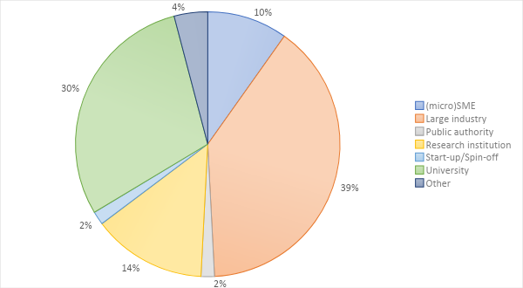
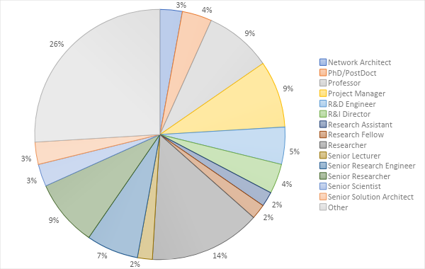
Figure 23. Percentage of participants per type of organization in Webinar 1

In addition to the 3 organizing projects, there was a representation from 41 other projects across the SNS 2023 and the SNS 2022 calls, as well as some of the ongoing 5G PPP projects, see Figure 24.

Figure 24. Participants per SNS project in Webinar 1
Figure 25 illustrates the participants’ satisfaction, with 70% indicating they were “very satisfied” and 30% “satisfied”.
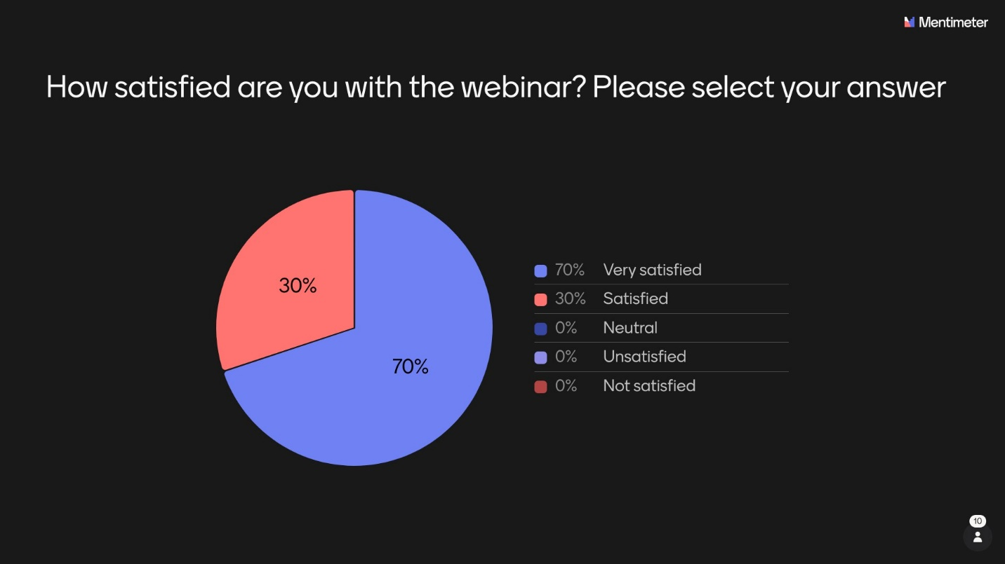
Figure 25. Participants satisfaction with webinar 1
Webinar #2 ‘Enhancements towards management of time-sensitive network’, 22 October 2024
Figure 26. Banner webinar 2 (source: DETERMINISTIC6G)
The webinar started with a presentation on “Wireless-friendly TSN scheduling” by Frank Dürr, Simon Egger and Lucas Haug from the University of Stuttgart and members of DETERMINISTIC-6G. Sandor Laki, from Elte and part of DESIRE-6G, talked about “Resource sharing policy enforcement in access aggregation networks”. Dave Cavalcanti from Intel and member of the PREDICT-6G project, closed the presentations speaking about “Wireless-aware TSN configuration and management”, as shown in Figure 26. Raheeb Muzafar, Senior Scientist Wireless Communications at Silicon Austria Labs and part of DETERMINISTIC-6G, hosted the webinar and moderated the lively discussion.
A total of 91 participants registered with a final attendance of approximately 55 participants. Germany and Spain accounted for most participants. There was a notable presence of non-EU countries, mainly Turkey, China and United Kingdom, as shown in Figure 27.

Figure 27. Number of participants per country webinar 2
Some 62% participants came from universities and research institutions. The presence of large industry was significant accounting for 27% of the total attendees. SMEs and public authorities were also amongst the audience, see Figure 28.

Figure 28. Percentage of participants per type of organization in Webinar 2
There were participants from 22 different SNS projects across calls in addition to the organizers, 5G-STARDUST and Hexa-X-II were the most represented, see Figure 29.

Figure 29. Participants per SNS project in Webinar 2
Some 67% of the participants that provided feedback indicated they were very satisfied, while the remaining 33% were satisfied, see Figure 30.
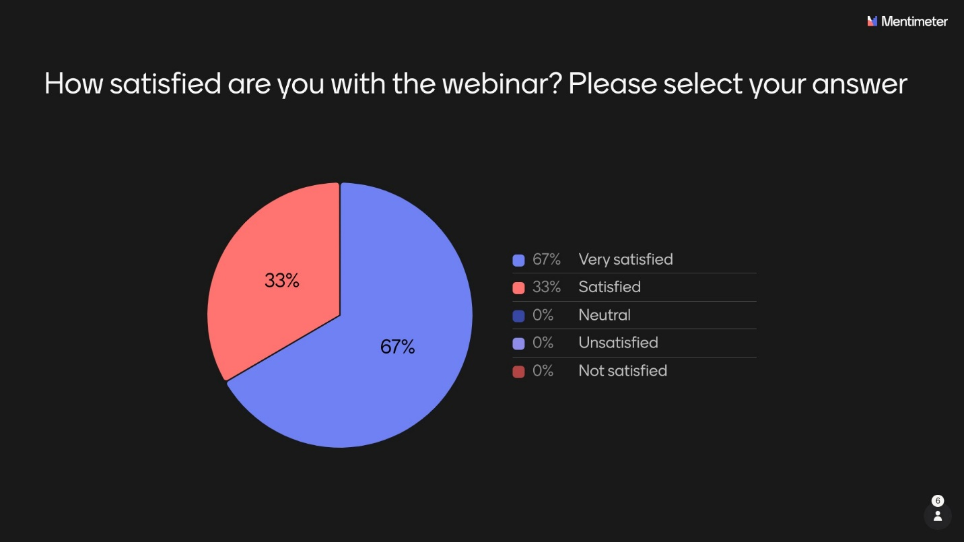
Figure 30. Participants satisfaction with webinar 2
Webinar #3 ‘Next challenges for 6G in deterministic and programmable mobile networks’, 20 May 2025
Figure 31. Banner webinar 3 (source: PREDICT-6G)
The third webinar was moderated by Antonio de la Oliva, associated professor at UC3M and PREDICT-6G coordinator. It began with a presentation on DETERMINISTIC6G titled ‘Lessons from DETERMINISTIC6G and the Way Ahead for 6G’, delivered by James Gross, professor at KTH. Gergely Pongracz, expert of programmable networks at Ericsson Hungary followed with a talk entitled ‘Beyond DESIRE6G: From AI and Cloud-Native to Goal-Native 6G’, see Figure 31. The session concluded with an animated discussion with the audience.
The third instance of the 6G-PD Webinar Series brough together over 50 participants across 21 countries, see Figure 32.

Figure 32. Number of registered participants per country webinar 3
Most participants were from academia (37%) and research institutions (30%). The presence of large industry was 16%, slightly lower than in the previous webinars, Figure 33.

Figure 33. Percentage of participants per type of organization in Webinar 3
A total of 36 SNS JU projects, from the three calls, were represented in the webinar. Ether and FIDAL had the highest number of participants, see Figure 34.

Figure 34. Number of participants per SNS project
Some 67% of the participants that provided feedback indicated they were very satisfied, while the remaining 33% were satisfied, Figure 35.
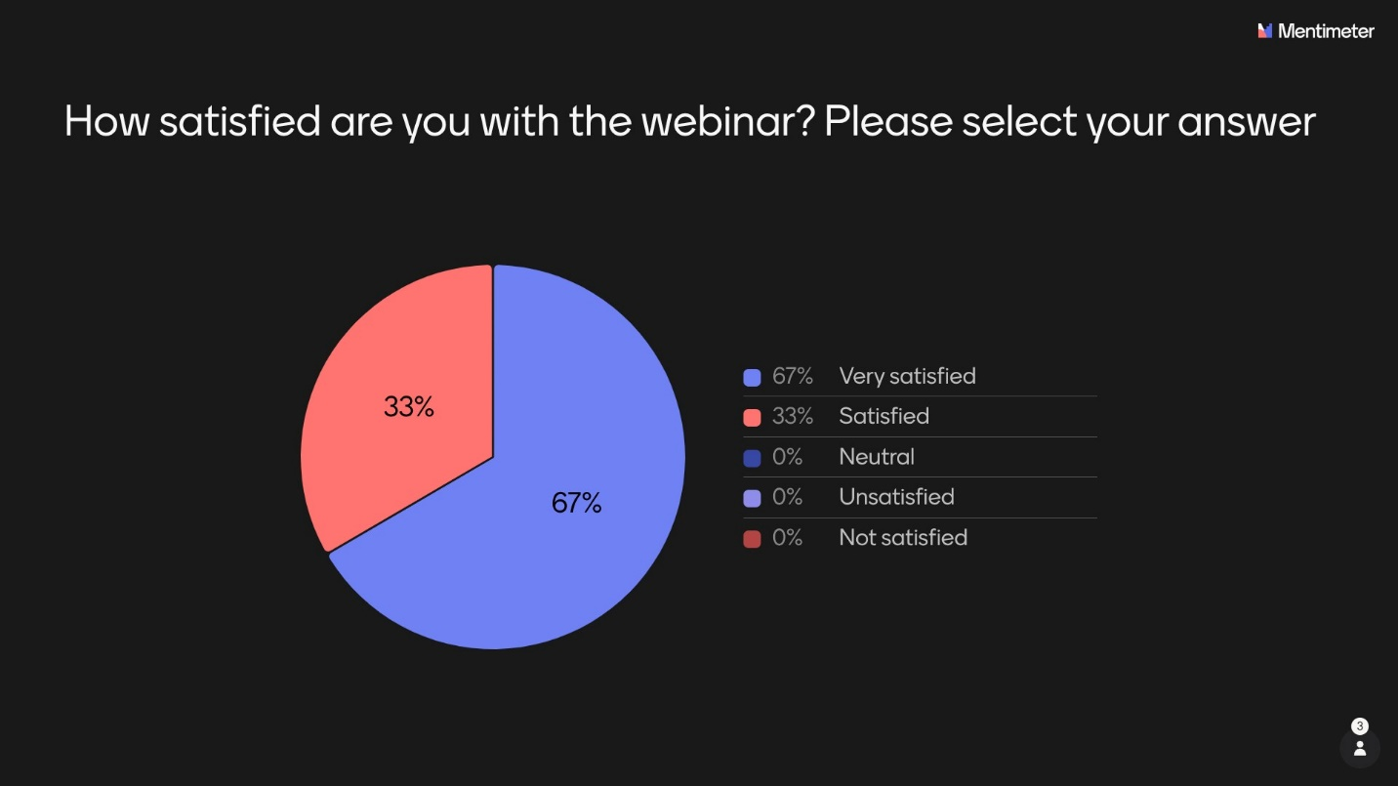
Figure 35. Participants satisfaction with webinar 3
International Conference on Mobile Computing and Networking (MobiCom 2024), 18-22 November 2024, Washington DC, USA
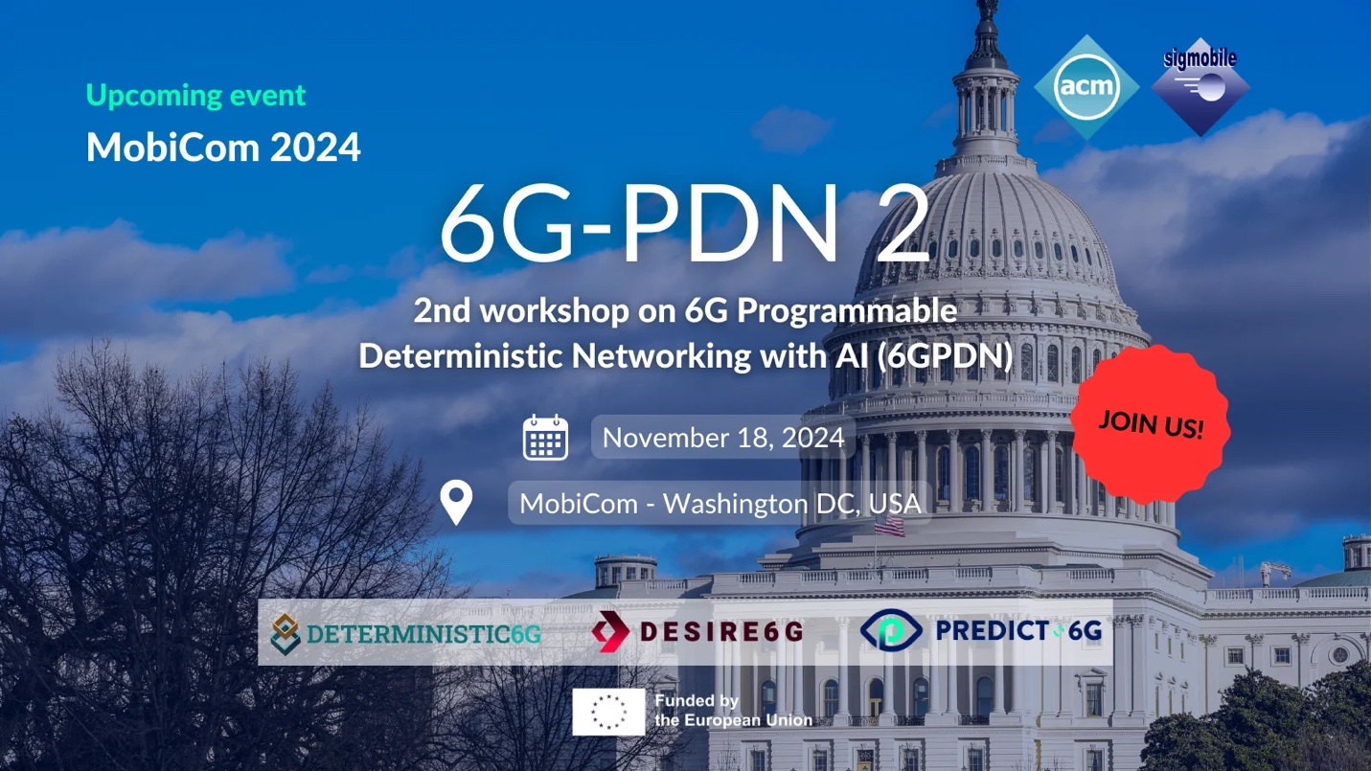
Figure 36. Banner for the 6G-PDN 2 workshop (by PREDICT-6G)
On the 18th of November 2024, DESIRE6G, DETERMINISTIC6G and PREDICT-6G co-organized the 2nd workshop on “6G Programmable Deterministic Networking with AI” (6G-PDN 2), see Figure 36. The objective was to discuss the roadmap and challenges in the technology areas of deterministic communications and deep network programmability in 6G to support future end-to-end time-critical applications.
EuCNC & 6G Summit
In the 2024 EuCNC edition, DESIRE6G and PREDICT-6G set up a joint booth: “Programmable deterministic networking: the PREDICT-6G and DESIRE6G approaches. In 2025, DESIRE6G and PREDICT-6G, in collaboration with MultiX, set up once again a joint booth: “Unfolding 6G’. PREDICT-6G designed the booth background in 2024 and 2025.
In addition to these events, the collaboration with DESIRE6G and DETERMINISTIC6G extended to workshops and webinars with other projects, knowledge transfer and collaboration in communication and dissemination actions, among others.

PREDICT-6G and the SNS ecosystem
PREDICT-6G has built strong collaborations with organizations and initiatives across the SNS and 6G ecosystem, resulting in valuable activities with a positive impact for all partners involved and the community at large.
The project has been very active in the SNS community. In addition to be part of the SNS Steering Board and Technology Board, PREDICT-6G partners are members of various SNS, 6G Industry Association (6G-IA) and NetworldEurope WGs. In particular, the Architecture WG, the SME WG, the Vision WG, the TMV WG, and the pre-standardisation WG. The technical papers are one of the outcomes of this collaboration (see 2.3.1.3).
PREDICT-6G also participated in various SNS-level activities such as the “IAFA Event Series #4-2: Second event on pre-Standardisation – Steps: 6G Standardisation Requirements” or the “SNS Stream B/D Projects Workshop on KPIs and KVIs”. As previously mentioned, it also participated in three editions of the EuCNC & 6G Summit, where the SNS community gathers annually.
In the last 18 months, PREDICT-6G reinforced its cooperation with other SNS JU projects mainly through joint workshops and webinars. For instance, the “AI and Security Webinar", included FIDAL, ELASTIC, Harpocrates, CONFIDENTIAL6G, RIGOROUS, FAITH and CUSTODES EU projects and the “Hexa-X-II standardisation workshop”, comprised HEXA-X-II, DESIRE6G and ADROIT-6G. Similarly, the 6G-PD Webinar Series, co-organized by PREDICT-6G, also attracted a great number of SNS projects across calls. These contributed to enrich the discussions on the matters addressed.
PREDICT-6G also cooperated with projects beyond Horizon Europe such as 5GSmartFact (MSCA-ITN) or Towards a Smart and Efficient Telecom Infrastructure Meeting Current and Future Industry Needs (TIMING), a project funded by the Spanish Ministry of Economy and Digital Transformation and the EU – NextGeneration EU, as well as various UNICO projects.
During this period, the interactions with SDOs such as the Third Generation Partnership Project (3GPP), IETF and the European Telecommunications Standards Institute (ETSI) have ramped up thanks to the work in standardisation (see Chapter 3).
PREDICT-6G also nurtured its relationship with the industry to guarantee the relevance of its research. In addition to the guidance of the External Advisory Board (EAB), the project also participated in industry-oriented fairs such as the Mobile World Congress, where IDE showcased a demo, or the Foro de Innovación y Tecnología (Forum of Innovation and Technology), 17 June 2025, Guipuzcua, Spain, where Manuel Lorenzo was part of an industrial panel.
Lastly, PREDICT-6G, especially its academic partners, invested important efforts in partaking in different events aimed at disseminating and promoting science among the public.

Standardisation
The previously published deliverable D5.3 presented the updated standardisation roadmap with four phases throughout the duration of the project and an overview of the standardisation landscape PREDICT-6G can possibly impact. As explained in D5.3, the output from WP2 and WP3 deliverables are taken as input by the Standardisation Advisory Committee (SAC) of PREDICT-6G to advise and steer the project on impacting leading SDO, implementing the EC’s recommendation on codes of practice for the management of standardisation across the European research community.
This present document D5.4 provides the additional standardisation activities of PREDICT-6G partners for the 2nd period of the project.

Project Innovations to SDO Mapping
Both WP2 and WP3 have identified a list of innovations (listed as innovation items) which are presented and described in further detail in D2.1, D2.2, D2.3, D2.4, D3.1, D3.2, D3.3 and D3.4.
While a dedicated section in the next chapter details these innovation items, this sub-section aims at mapping the innovation items to potential SDOs and WGs within an SDO with an explanation of what standardisation capabilities a specific innovation item offers.
Table 7 provides an overview of all SDOs and their WGs that were relevant to PREDICT-6G. The relevance is justified by the opportunity to standardize innovation from the technical WPs of the PREDICT-6G project.
Table 7. Project Innovation Items and their Standardisation Potential
Innovations | SDO | WG | Standardisation Opportunity
Zero-Touch Control for Deterministic End-to-End (E2E) Services | ETSI | ZSM-009 | Zero touch network & Service Management (ZSM) architectural and network automation concepts evolutions for lifecycle management of deterministic services and their automatic control based on closed-loop automation
Advanced KPI Monitoring and prediction | 3GPP | SA2/CT | Support of multi-domain E2E service provisioning via KPI monitoring
Advanced KPI Monitoring and prediction | ETSI | ZSM-002  ZSM-009 | Distributed monitoring and data management in a multi-domain environment for multiple purposes including Closed Loops (CLs) for network and service automation
Advanced KPI Monitoring and prediction | ETSI | ISAC | Work Item #1 focuses on use cases towards sensing-aided communication in 6G and KPI monitoring, and prediction can be brought to this newly established Industry Specification Group (ISG).  Work Item #3 focuses on Radio Access Network (RAN) and system architecture for Integrated Sensing and Communications (ISAC) in 6G and the support for advanced monitoring and prediction capabilities in 3GPP for ISAC is a promising topic to contribute.
AI-Based Resource Allocation | 3GPP | SA3 | Secure model transfer between User equipment (UE) and network is an on-going activity in 3GPP supporting multi-domain Public Land Mobile Network (PLMN) scenarios is of key interest to SA3.
Management of Zero-Determinism Networks | ETSI | ZSM-015 | Autonomous adaptation of the network’s service to external requirements such as determinism (including time sensitivity) is part of the synergies between DTs and NDTs. In this context, NDTs could involve mechanisms created for the management of zero-determinism networks to improve the deterministic capability of their twinned physical networks.
Management of Zero-Determinism Networks | IETF | PCE | With path computation being a dedicated E2E and domain-specific Management Service, there is plenty of potential to impact this IETF WG to support path calculation in a multi-domain environment.
Support of Domains without Determinism Capabilities | IETF | DetNet | Integration of domains without Layer 2 (L2) determinism into multi-domain data plane. Potential standardisation in YANG models for non-deterministic domains
Wi-Fi Integration with DetNet Data Plane | IETF | DetNet | Enabling support to manage Wi-Fi domain with determinism support in an end-to-end fashion.
Wi-Fi Integration with DetNet Data Plane | IEEE | 802.11 | Support for the integration of Wi-Fi into DetNet on both control and data plane.
Data Unit Groups for multi-domain Data Plane | 3GPP | SA2 | Support for Time-Sensitive Networking (TSN) over Protocol Data Unit (PDU) Set innovations and extension of PDU Sets to any IP-based traffic (not just video via RTP).
Data Unit Groups for multi-domain Data Plane | IETF | INTAREA | Potential standardisation of proposed IP header extension to enable Data Unit Group.
Data Unit Groups for multi-domain Data Plane | IEEE | 802.1cf | Enable support for packet/flow detection based on proposed IP header extension.

Standardisation Contribution
The project achieved 31 meaningful contributions to standards and pre-standards development organizations, such as 3GPP, IETF, IEEE, ETSI, O-RAN and Next Generation Mobile Networks (NGMN), as shown in Figure 37. The distribution of all contributions is illustrated in Figure 37.
and comprises 20 contributions to IETF, 6 to ETSI, 1 to 3GPP, 1 to IEEE, 1 to O-RAN and 2 to NGMN.

Figure 37. PREDICT-6G contributions to SDO and pre-standardization organizations
Figure 38 depicts the number of adopted contributions, i.e., 10 in total with 7 in IETF and 3 in ETSI.

Figure 38. Adopted contributions per SDO
In addition to the achieved standard contributions per SDO and pre-standards forum, Figure 39 provides a pie chart for all achieved contributions across PREDICT-6G WPs. As can be seen, 13 contributions were related to WP2, 10 to WP1 and 8 to WP3.

Figure 39. Split among WPs of PREDICT-6G contributions to SDO and pre-standardization
Table 8 shows the exhaustive list of contributions contributed to SDO and pre-SDO WGs during the entire duration of the project.
Table 8. PREDICT-6G (pre-)standards contributions
Quarter | SDO | WG | Status | Title and Authors
Q1 2023 | 3GPP | SA2 | Adopted | Liaison Statement on the Granularity of PDU Set Integrated Handling  Chathura Sarathchandra, others
Q1 2023 | O-RAN | WG9 | Accepted | DetNet Overview at O-RAN WG9 Xhaul Packet Switched Architectures and Solutions (XPSAAS) periodic call.  Luis M. Contreras
Q1 2023 | IETF | MOPS | Accepted | Media Operations Use Case for an Extended Reality Application on Edge Computing Infrastructure  Renan Krishna, Akbar Rahman
Q1 2023 | IETF | RAW | Individual Submission | MIPv6 RAW mobility  Carlos J. Bernardos, Alain Mourad
Q1 2023 | IETF | RAW | Individual Submission | RAW multidomain extensions  Carlos J. Bernardos, Alain Mourad
Q1 2023 | IETF | RAW | Adopted | Operations, Administration and Maintenance (OAM) features for RAW  Fabrice Theoleyre, Georgios Z. Papadopoulos, Greg Mirsky, Carlos J. Bernardos
Q1 2023 | IETF | DETNET | Adopted | Deterministic Networking (DetNet) Controller Plane Framework  Andrew G. Malis, Xuesong Geng, Fengwei Qin, Balazs Varga, Carlos J. Bernardos
Q1 2023 | IETF | RAW | Adopted | RAW Use-Cases  Carlos J. Bernardos, Georgios Z. Papadopoulos, Pascal Thubert, Fabrice Theoleyre
Q1 2023 | IETF | DETNET | Adopted | Framework of Operations, Administration and Maintenance (OAM) for Deterministic Networking (DetNet)  Greg Mirsky, Fabrice Theoleyre, Georgios Z. Papadopoulos, Carlos J. Bernardos, Balazs Varga, János Farkas
Q1 2023 | IETF | DETNET | Individual Submission | DETNET Multidomain Extensions  Carlos J. Bernardos, Alain Mourad
Q2 2023 | ETSI | MEC | Proposed Solution | MEC Application Package  Giada Landi
Q3 2023 | ETSI | MEC | Proposed Solution | MEC Application Package  Giada Landi
Q3 2023 | IEEE | 802.11 | Proposed Solution | Scheduled channel access  Dave Cavalcanti, Das Dibakar
Q4 2023 | IETF | PCE | Individual Submission | Path Computation Based on Precision Availability Metrics  L. M. Contreras, F. Agraz, S. Spadaro
Q4 2023 | ETSI | MEC | Accepted Tdoc | MEC Application Package  G. Bernini
Q4 2023 | ETSI | MEC | Accepted Tdoc | MEC Application Package  G. Bernini
Q4 2023 | NGMN | 6G Requirements | Draft Text for Whitepaper | ISAC Usage Scenario and 3GPP Implications  Sebastian Robitzsch
Q4 2023 | NGMN | 6G Requirements | Presentation on ISAC Draft | ISAC Usage Scenario and 3GPP Implications  Sebastian Robitzsch
Q1 2024 | IETF | DetNet | Adopted | Framework of Operations, Administration, and Maintenance (OAM) for Deterministic Networking  Carlos J. Bernardos
Q1 2024 | IETF | DetNet | Individual Submission | Requirements for Reliable Wireless Industrial Services  Carlos J. Bernardos
Q1 2024 | ETSI | ISG ISAC | Use Case | TP on Collaborative robots based on digital twinning  - ISC(24)000042  Sebastian Robitzsch
Q2 2024 | ETSI | ISG ISAC | Adopted | TP on Collaborative Robots Based on Digital Twinning - ISC(24)000087r1  Sebastian Robitzsch
Q3 2024 | IETF | DetNet | Individual Submission | Using Deterministic Networks for Industrial Operations and Control  Luis Contreras
Q3 2024 | IETF | DetNet | Individual Submission | Extensions to enable wireless reliability and availability in multi-access edge deployments  Carlos J. Bernardos , Alain Mourad
Q4 2024 | IETF | DetNet | Individual Submission | Data Unit Groups for DetNet-Enabled Networks  Sebastian Robitzsch, Luis Contreras
Q4 2024 | IETF | BM | Individual Submission | Calibration of Measured Time Values between Network Elements  Luis Contreras
Q4 2024 | IETF | DetNet | Individual Submission | Terminal-based joint selection and configuration of MEC host and DETNET-RAW network  Carlos J. Bernardos , Alain Mourad
Q4 2024 | IETF | DetNet & DMM | Individual Submission | MIPv6 DETNET-RAW mobility  Carlos J. Bernardos, Alain Mourad
Q1 2025 | IETF | DetNet | Individual Submission | DetNet multidomain extensions  Carlos J. Bernardos, Alain Mourad
Q1 2025 | IETF | BM | Individual Submission | Calibration of Measured Time Values between Network Elements  Luis Contreras
Q1 2025 | IETF | PCE | Individual Submission | Path Computation Based on Precision Availability Metrics  Luis Contreras

In summary, PREDICT-6G managed to deliver 31 contributions to SDOs, an achievement that more than doubles the set KPI of the DoA of 15 contributions.

Exploitation and Innovation
PREDICT-6G had the ambitious plan to impact with substantial contributions the innovation capabilities of its consortium partners, both at the European and at international scenes. The former is mainly composed of the research and industrial ecosystem driven by academia and industries having R&D centers in Europe and is impacted via the interaction with other EU-funded research projects, especially of the SNS family, and other initiatives related to the technical topics in focus of the project. The international scene is instead mainly impacted by contributions to SDOs, by publishing at prestigious journals and providing contributions to key international conferences, as well as by collaborating with associations spanning outside of Europe, e.g., the Big Data Value Association (BDVA), or with alliances, e.g., the Next Generation Mobile Networks (NGMN).
Such plan was practically split in two main directions: internally and externally to the project. Internal innovation was fostered thanks to the PREDICT-6G Innovation Program, meant to increase the innovation acumen of project partners thanks to a set of actions driven by the Innovation Manager (Valerio Frascolla, INT) of the project. Externally innovation was fostered by the measures mentioned in the previous paragraph and, e.g., by filing patents and protecting Intellectual Properties (IP) generated by consortium partners, by creating new or enhanced products, and by showcasing Proof of Concepts (PoC) and other means of impacting targeted markets with project results.

Exploitation

IP and patents

[removed in the public version].

Partner-Specific exploitation plans updates
[removed in the public version].

Innovation

Innovation Programme
Dealing within an EU-funded research project with the different needs and approaches to innovation coming out of the diverse set of partners (SME, Industry, Academia, Research centers), is indeed an additional challenge that adds to the technical challenges each project must face. For that reason, an Innovation Program was run along the duration of the project, steered by the consortium Innovation Manager, in tight collaboration with WP leads, PREDICT-6G Technical Manager and Coordinator, and with active contributions from all consortium members.
The Innovation Program focuses on enhancing the consortium members’ business acumen and capabilities of handling innovation in the most effective way. It consists of a set of activities performed together by the consortium partners, and, as such programs are difficult to be implemented in a virtual manner, it is key that some time is carved out for that specific activity during the face-to-face General Assemblies of the project.
Along the project lifetime 2 Innovation Workshops were held, followed with a project-wide activity in identified the innovation items, described in the technical Deliverables. In what follows the methodology used to find those innovation items is described. But before doing so, we provide some details on the 2 held Workshops (WSs).

First Innovation Workshop, Bucharest 10.2023
The scope of the Innovation Workshop was, via a game-based approach, to stress some common mistakes people incur in, when dealing with innovation actions. As the time dedicated to the workshop was around 40 minutes, it was possible to run one game and derive some hints at how people behaved during its execution. The workshop was facilitated by Dr. Frascolla, who he has been trained in different aspects of methods, techniques and best practice to foster innovation within and outside the company he works for. For example, he obtained the CSM (Certified Scrum Master) and the CSPO (Certified Scrum Product Owner) certifications for agile project management techniques using SCRUM, He run an innovation program within the broad system engineering teams of Intel, where, through brainstorming sessions, new ideas are fostered, nurtured and worked on so to become real in-feeds into future products. He has also been trained within the Intel Learning program in communication strategies, in effective communications, in netiquettes, and to be an internal mentor and coach for his colleagues.
Game: How high can you get?
The game followed some rules, which were communicated to all participants, split in four different groups, and playing together in the same room, each one given a table and a set of items as described below.
Time:
15 min per round (2 rounds are possible, if deemed the case)
Target:
- Build the highest possible tower with the objects at hand, that can stand by its own for 10 seconds.
Available Items:
Participants were allowed to use all items at their disposal in the room, and could make use of:
- Some pieces of paper.
- 4x 30 cm sticky band (1 per Table).
- 4x Scissor (1 per Table).
Additional optional rules:
- Team members cannot talk among themselves (note implemented).
- Sticking to the ceiling is not allowed (not implemented).
Scope is to understand the following:
- Discuss how people interact among themselves in a situation of stress.
- Highlight winning strategies.
- Understand what went wrong and elaborate why.

The game was very felt by all participants, who started to engage with a lot of transport in trying to get the highest possible self-sustaining tower, as shown in Figure 40.

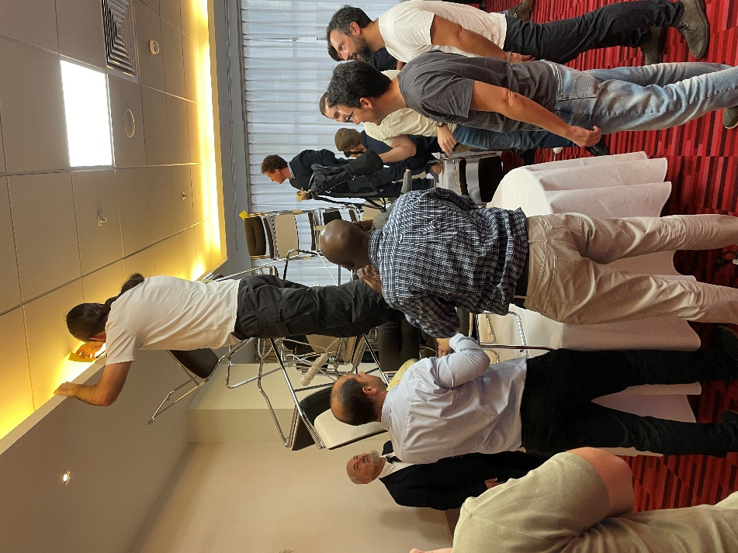
Figure 40. One of the team trying to get as high as possible
The winning team is shown in the next figure. The winning factor was the innovation contained in the fact that ceiling tiles could be removed to increase the height of the tower. That was indeed a differentiating factor and a winning idea.
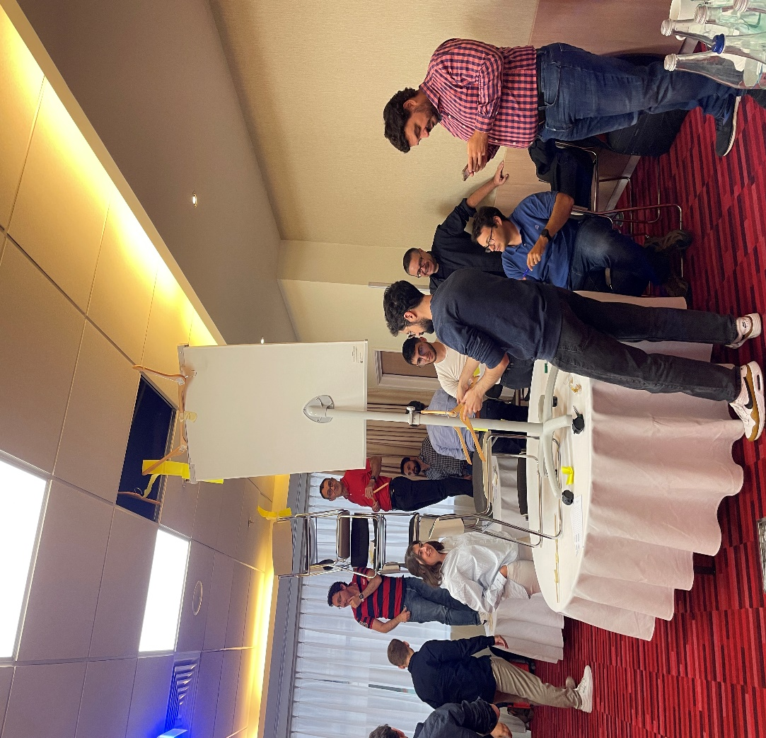
Figure 41. The winning team
At the end of the game, a short lesson learnt session was run, to share what were the problem each team suffered under a condition of stress and competition against the other teams.

Second Innovation Workshop, Madrid 01.2025
A second workshop was run during the General Assembly held in Madrid at the beginning of 2025. The proposed challenge was very similar to the one already run in Bucharest, i.e., the game “How high can you get?” to assess whether any lesson was learnt out of the previous WS, and to which extend, after some time, the participants adopted some of the winning approached shown in the previous WS.
The rules this time were slightly altered:
- Each team has 5 min to complete the task
- You can only use paper and sticky band
- You must elect a person who will report how it went (30 sec)
- You may decide to name a person who takes decision
No team opted for the last option.
As a matter of fact, the three teams among which the consortium participants were split showed a more scientific approach to the game, this time a 1 min of design was followed by all teams. Results varied a lot, depending on the winning idea that was followed by each team. This time the winning team, see Figure 42 adopted a more conservative approach, which resulted in a stable structure that could stand by its own for a few seconds. Unfortunately, other approaches, a bit less structured and rushed in their design, did not make it to create a stable stower, see Figure 43.
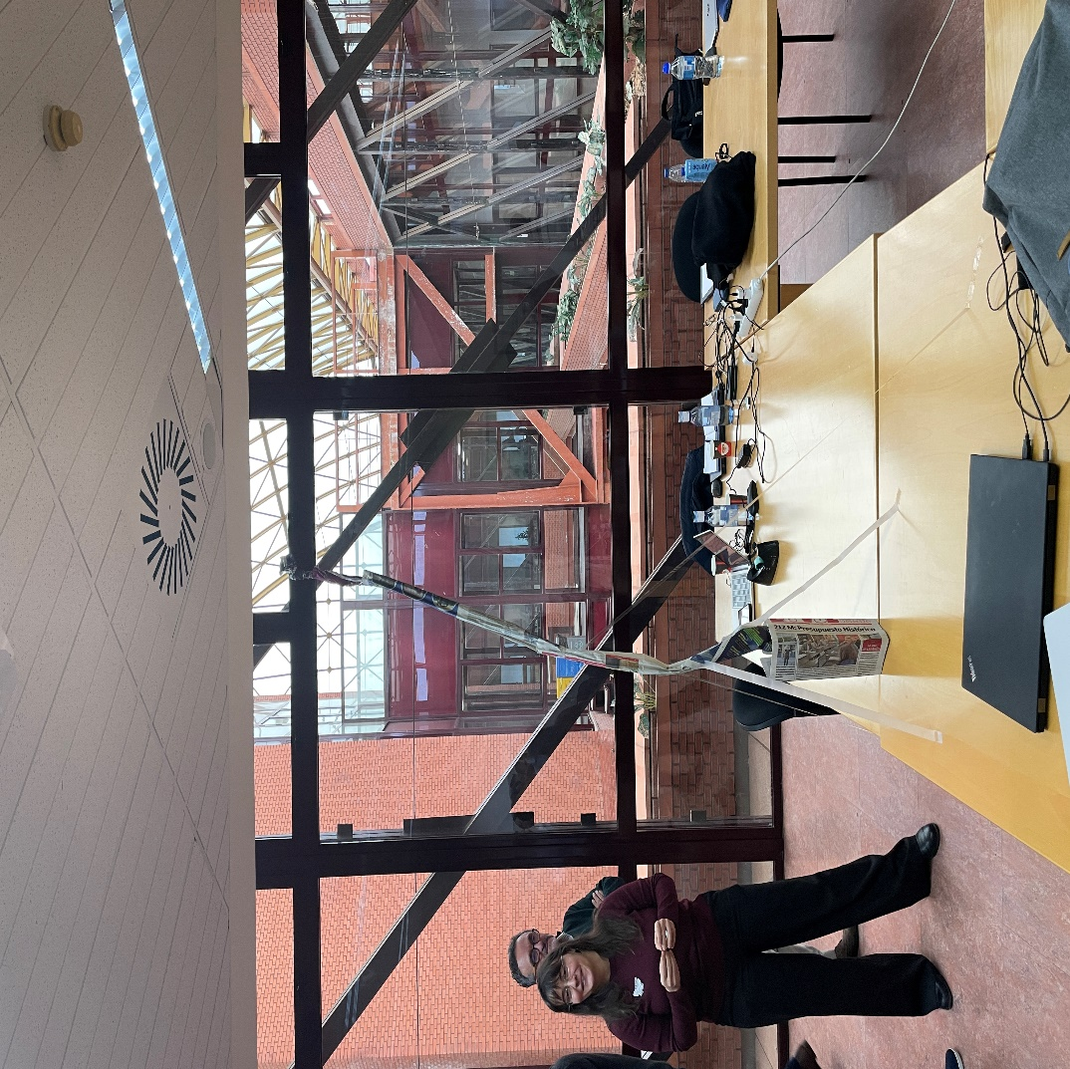
Figure 42. The winning team and the Tower created with the allowed material
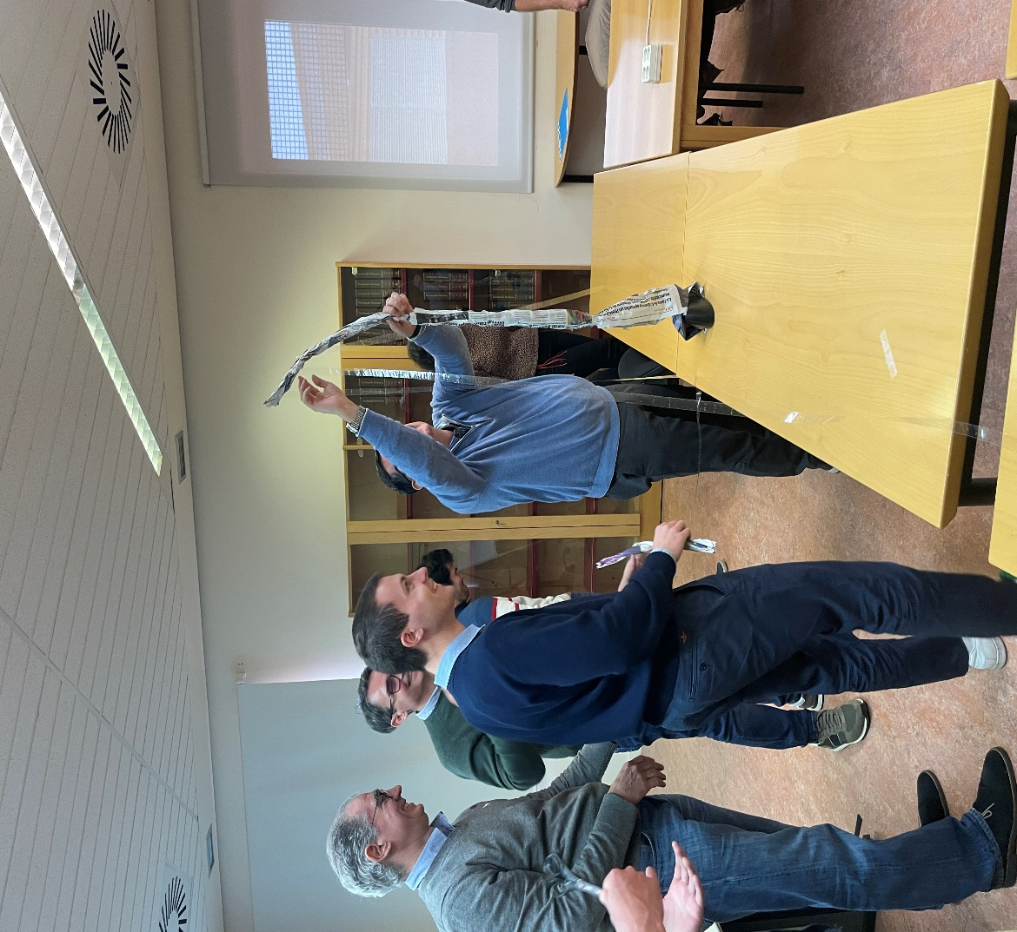
Figure 43. A less successful attempt performed by another team
In summary, the 2 run WSs were considered useful to stress some common mistake researchers do when dealing with a non-disciplined approach in managing ideas and therefore innovation actions.

Innovation per WP
All project partners participated in the cross-WP action of defining the main innovations that composed the main activities of PREDICT-6G. Such innovations have the potential to make a real breakthrough in the academic and industrial ecosystems alike, as currently there’s no agree-upon approach, neither in literature nor in standards, on how to improve the predictability of industrial communication networks in heterogeneous environments, where multiple access strata, e.g., 3GPP/cellular and IEEE/Wi-Fi, are used.
Adopting the learnings of the WSs run in the Innovation Programs, all partners contributed to the creation of two lists related to the innovation content of their work, which in this context we called innovation items. A first list was compiled per partner and second one was completed per WP. The work was steered by PREDICT-6G Innovation Manager under WP5 activities, in tight collaboration with WP2 and WP3 Leads; the outcome was aligned with the architectural and requirements work of WP1, and with the technical content of WP2 and WP3. WP4 confirmed the obtained expected results by running the planned PoCs.
In what follows it is sketched the work done by each partner, as a first step in the definition of the Innovation Item per partner. Partners were also asked to map their innovation Item in the WP they planned to make use of it.
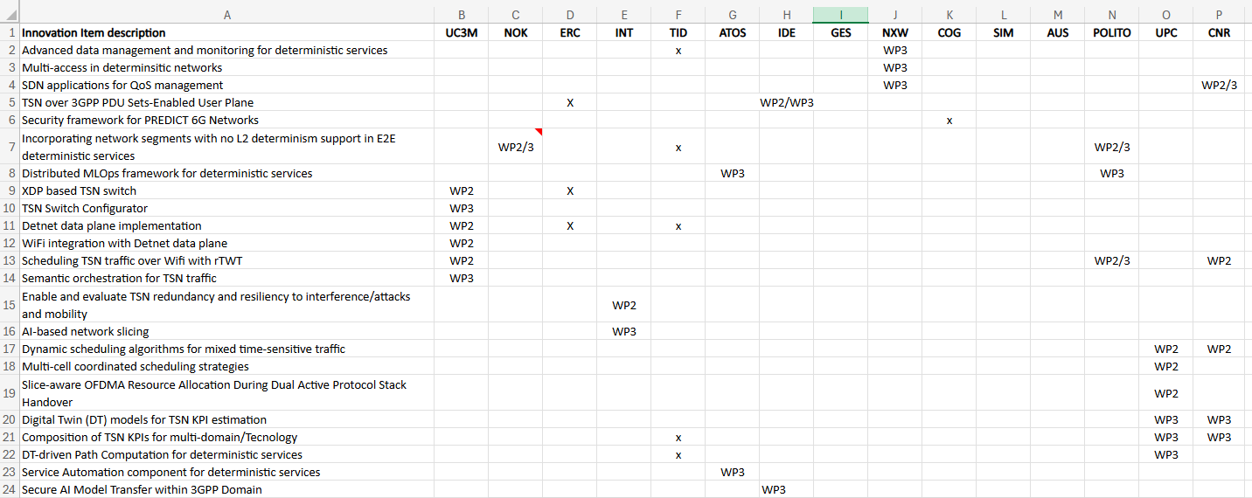
Figure 44. Partner-specific Innovation Items, mapped into WPs
It is worth noting that an ‘x’ indicates that the partner expects to make use of that innovation items in all WPs of the project, including WP4. WP4 is almost not mentioned as it was the PoC and integration WP, so not much research nor innovation was expected coming out of that WP.

In a second step in the flow to create the project Innovation Items, partner specific-innovation items were clustered in more general Innovation Item (per WP), as listed in what follows for WP2 and WP3, the technical WPs of the project.
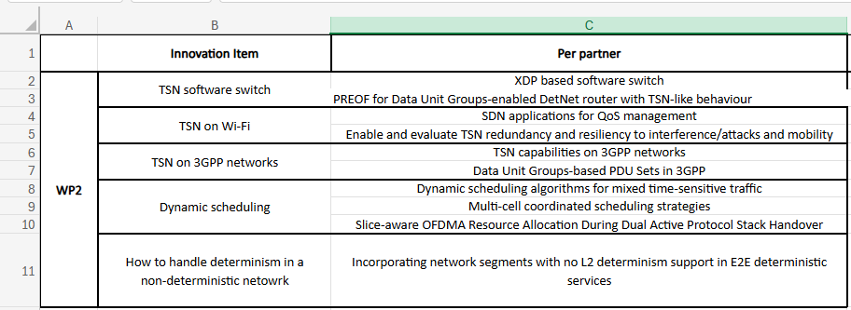
Figure 45. Project-Innovation Items as clusters of Partner-Specific Innovation Item for WP2

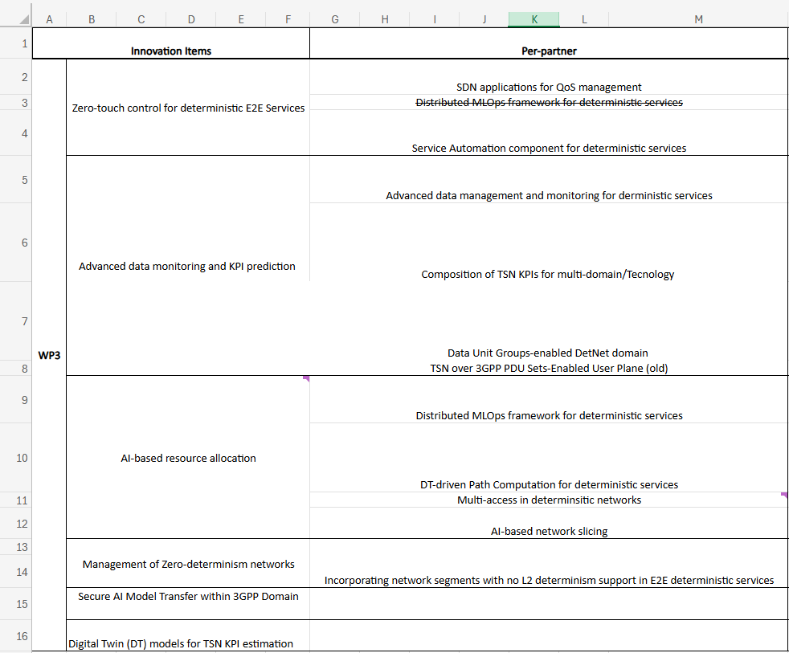
Figure 46. Project-Innovation Items as clusters of Partner-Specific Innovation Item for WP3
It is worth noting that the second item in the innovation item “Zero-touch control for deterministic E2E service” was cancelled as the same activity was covered by the entry “AI-based resource allocation”.
The last two items of Figure 46 were found and added along the second year of the project.
For more info on the content of the Innovation Item, one can refer to the Deliverables of WP2 and WP3. In this section only the method used to find them is described.
For completeness of the information in the next two sub-paragraphs we list the technical WP-specific main streams of innovation.

Innovation related to WP2
WP2 focused on the research and innovation in the data plane, and its objective was to enhance the determinism of that plane. There are 3 big areas of innovation:
- Fundamental research and innovations: this involves all the activities related with the research of novel mechanisms that enhance the determinism at L2. The research and innovation activities are grouped by area and includes Dynamic scheduling for 3GPP and Wi-Fi, TSN on Wi-Fi, TSN on 3GPP, Localization and Sensing, Non-deterministic networks. Selected innovation will be showed in the four demonstrations planned for the project.
- Novel Data Plane Open Application Programming Interfaces (APIs): New APIs for managing the multi-technology, multi-domain data plane.
- Multi-Domain scenarios: includes innovations in the integration of DetNet as multi-domain layer in charge of guarantee the E2E determinism.

Innovations related to WP3
WP3 worked on several innovation items that follows 4 main strands for control, monitoring, resource allocation of E2E Deterministic services on a heterogeneous data plane, and MDP.
- Zero-touch control for deterministic services. Aims at incorporating solutions that allows the lifecycle management of E2E deterministic service, enabling at the same time closed-loop network automation. This would include AI/ML support for services status analysis, policies and actuators for service QoS tuning and recovery, in line with ETSI ZSM standardization.
- Advanced KPI monitoring and prediction. This strand investigates solutions for i) E2E service KPI collection and management that include continuous monitoring, differentiated data access, run-time data source selection, ii) KPI composition and modelling for multi-technology data sources normalization and KPI estimation exploiting NDT techniques.
- AI-based resource allocation. Considers several innovation paths for both services and AI resource management. In particular, for the service side, the focus is on i) AI/ML-driven resource allocation that takes into account the characteristics of the different technological domains, the resource availability and the possible effects on existing deterministic service, ii) advanced algorithms exploiting NDTs features for E2E and local domain optimal path computations and iii) AI mechanisms to enable slicing in mobile multi-access networks. In terms of AI resource management, the current investigation is focused on the secure transfer of AI/ML modes within the 3GPP domain.
- Management of Zero-determinism networks. PREDICT-6G’s control plane aims at incorporating network segments that offer no L2 determinism support as part of E2E deterministic services.

Exploitation Workshop
In June 2025, PREDICT-6G organized an Exploitation Workshop of 90 minutes, where each project partners was allocated a 5 minutes slot to showcase its main project results. Following that presentation it started a question-and-answer sessions between the presenters and the attendees, who posed some business-related questions, aiming at maximizing the follow-up actions of the project partners in the productization of the identified main innovation items of the project.
Attendees of the WS were all consortium partners, members of the EAB of the project, and colleagues of the consortium members not involved in the project and covering business or market-related functions in their own companies (for instance for Intel the Marketing manager of the Industrial manufacturing Business Unit attended the call).
The Workshop was run by Valerio Frascolla and attended by more than 40 people.
The workshop was recorded, and partners will start, after project end, implementing the suggestions given by the EAB members, and the other participants of the WS.
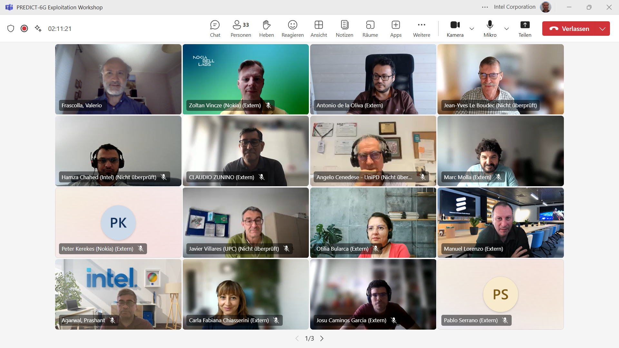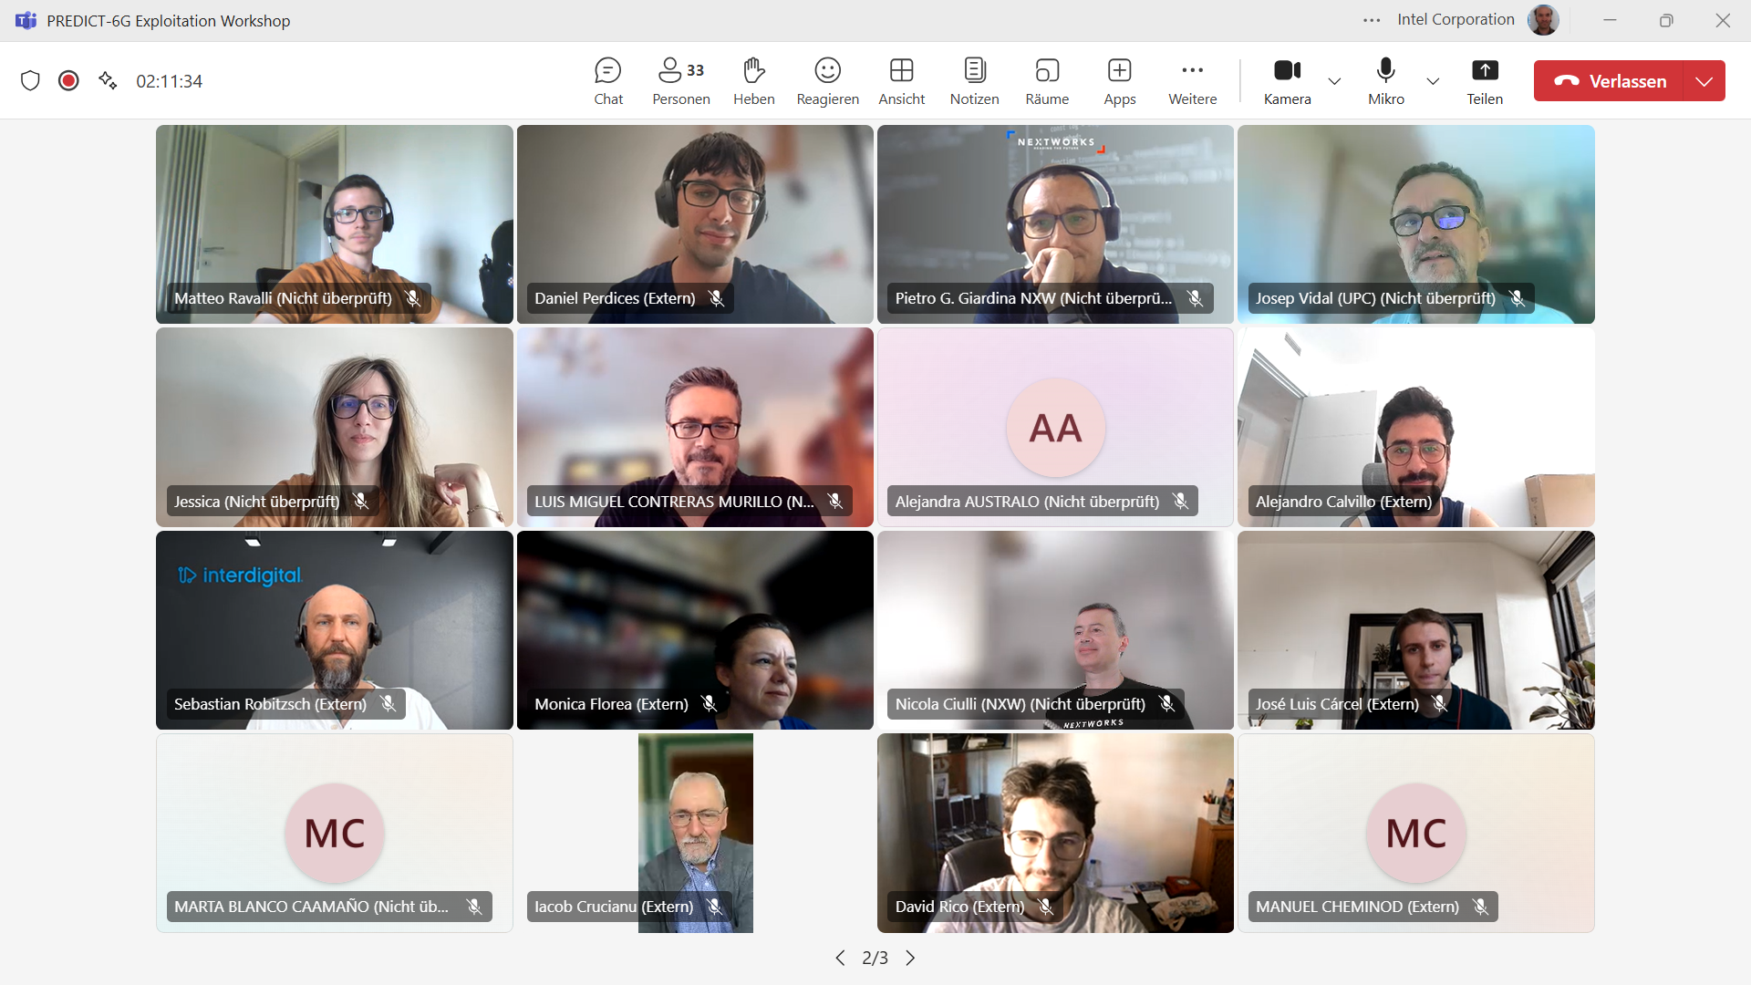
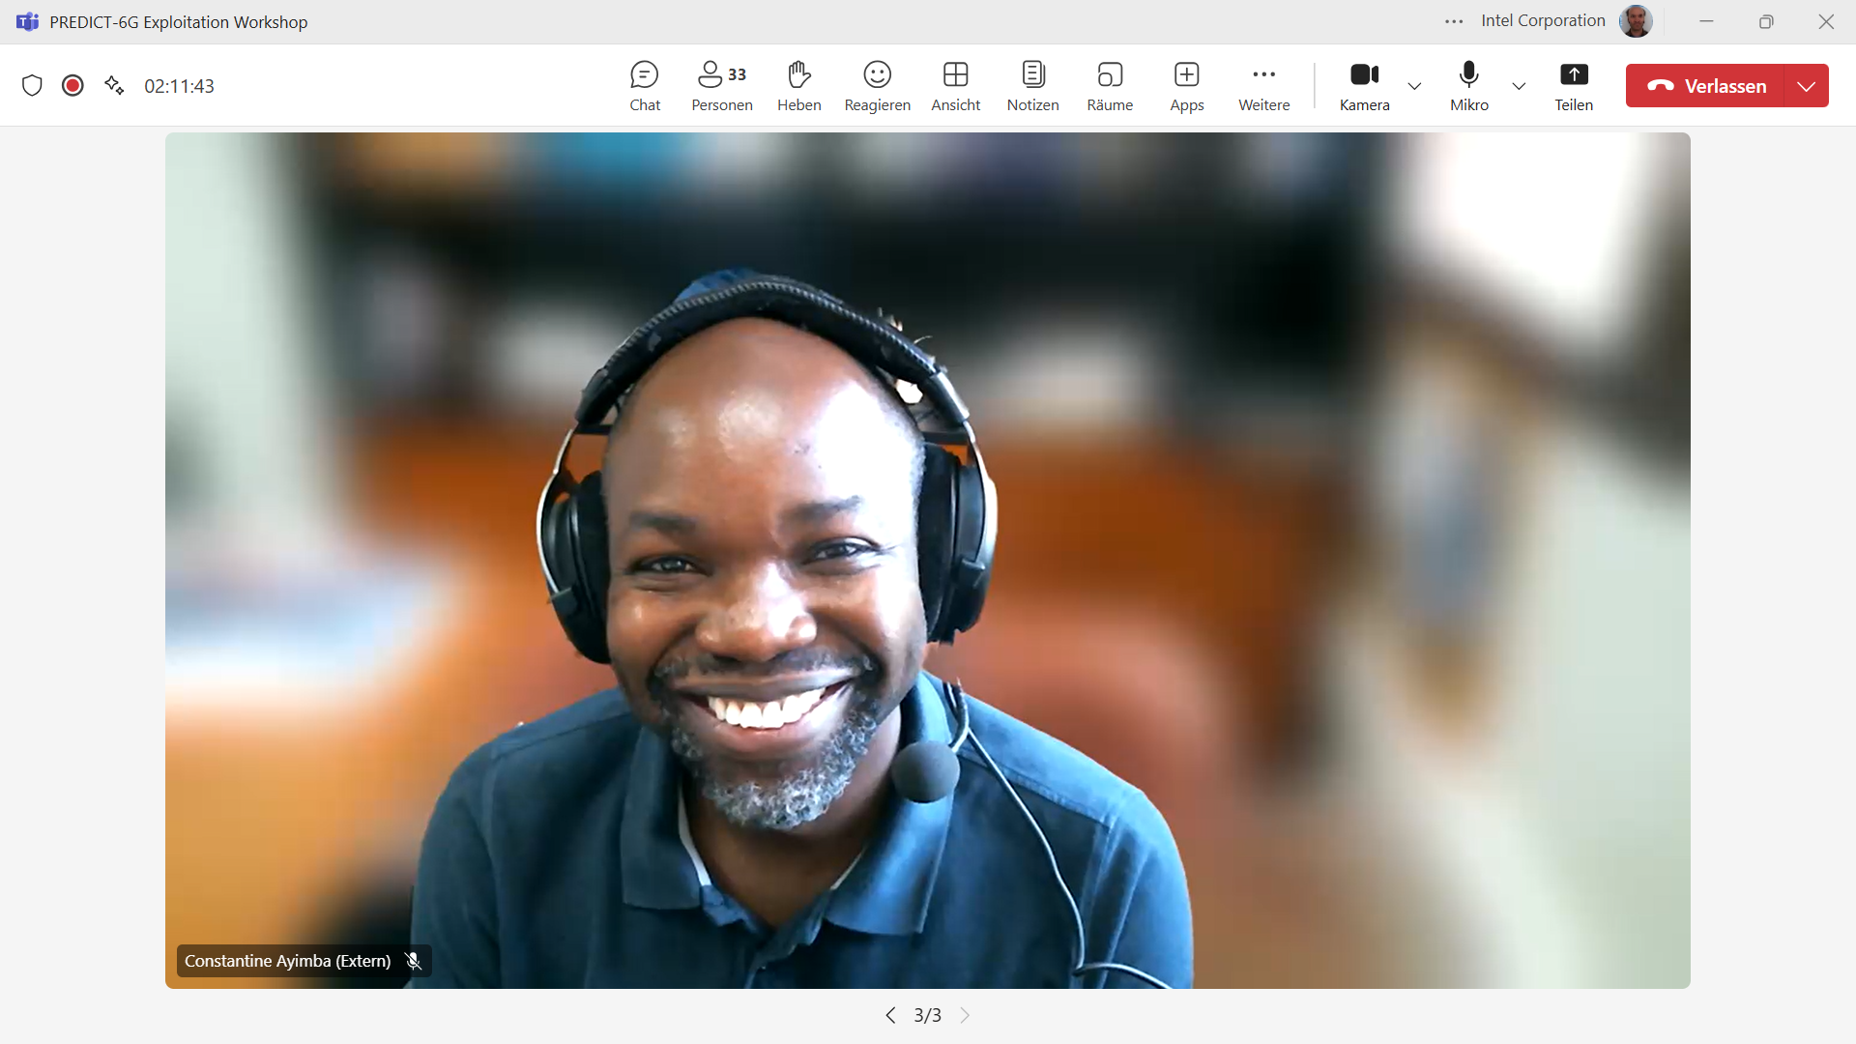
Figure 47. All-in pictures of the Exploitation Workshop attendees

Open Science (OS)
Following the guidelines established in the D5.1 Data Management Plan (DMP), the PREDICT-6G Consortium has continued to apply and refine its Open Science strategy throughout the project, reinforcing our commitment to make research results openly accessible and to follow FAIR (Findable, Accessible, Interoperable, and Re-usable) principles.
As a living document, the DMP has had 3 updates since its first publication to include the agreements reached by the consortium in OS dedicated meetings, the comments from the reviewers, the new partners and the updated OS protocols.
The DMP objectives have been fulfilled thanks to the application of a dissemination form and the OS protocol. The dissemination form was early implemented in the project, as a tool to help the partners to share information among the Consortium and coordinate the OS effort and has been extensively used by all the partners. Through experience, it has been modified to make its use simpler and to include the Dataset outputs. The OS publication protocol, updated in October 2023 and shared during the Bucharest General Assembly, has proven to be an effective tool to standardize and simplify the publication process for all partners. It includes clear steps for uploading materials, linking Zenodo entries with GitLab repositories, and associating datasets to scientific outputs.
Zenodo was the primary platform for sharing public outputs of the project. The PREDICT-6G Zenodo community has grown significantly over the last 18 months, and its use was fully integrated into the dissemination workflow of the project. Scientific papers, public deliverables, dissemination material, and datasets have all been published through this channel, with continuous monitoring of Zenodo figures and impact.
Throughout the RP2, the following actions and results can be highlighted:
- Regular evaluation of our OS objectives and verification of partner implementations against the agreed updates.
- Continuous dataset monitoring and maintenance of the Zenodo repository to ensure all public documents are available and properly referenced.
- Tracking of publication impact and Zenodo usage metrics to inform future dissemination strategies.
- Preparation and delivery of an updated DMP version, incorporating the latest consortium agreements on OS procedures.
- Dedicated meetings (including a project-wide OS General Meeting) to improve OS outcomes and refine dissemination protocols: Online meeting in December 2023, June 2024 in Antwerp, October 2024 in Budapest Plenary Meeting, online meeting in December 2024 and January 2025 in Madrid Plenary Meeting.
- Attendance to WP5 sessions to align OS activities with overall project dissemination and to prepare for an end-of-year OS workshop.
- The project website was continuously updated with demo videos, scientific publications, presentations, newsletters, deliverables, event announcements, and news highlights, ensuring a one-stop portal for all stakeholder engagement and outreach.

The GitLab repository under UC3M’s domain continues to mirror Zenodo entries, containing structured subgroups for datasets, code, and implementation artefacts. This dual-archiving approach ensures both static citation and live updates for future researchers.
The Output Manager of the project, in collaboration with T5.1 and T5.2, has regularly monitored compliance with the DMP, supported Zenodo and website management, updated the Sygma portal and SNS-JU questionnaires, and oversaw the E2E publication workflow.
All partners showed their commitment to the “as open as possible, as closed as necessary” principle.

Conclusions
The PREDIT-6G consortium has finalized the work at month 30 and managed to deliver more than was committed in the DoA on all project KPIs.
That was achieved by the very good co-work showed by all consortium partners along the duration of the project, and thanks to the guidance provided by the Innovation Program, run along the project lifetime.
Al consortium partners are committed to continue the exploitation actions related to the main results obtained by the project, as the way described in the section related to the partner-specific exploitation plans. We can already tell that there are new running EU-funded projects, e.g., MultiX, that are continuing the efforts undertaken but some of the partner of PREDICT-6G, giving continuity to the research effort toward a successful exploitation of the project results in future products addressing a diverse set of market verticals.

Appendixes

Appendix 1: Scientific publications in journals
Table 10. PREDICT-6G papers published in journals
 | Citation
1 | W. Chen et al., "5G-Advanced Toward 6G: Past, Present, and Future" in IEEE Journal on Selected Areas in Communications, vol. 41, no. 6, pp. 1592-1619, June 2023, doi: 10.1109/JSAC.2023.3274037.
2 | S. Tripathi, C. Puligheddu, S. Pramanik, A. Garcia-Saavedra and C. F. Chiasserini, "Fair and Scalable Orchestration of Network and Compute Resources for Virtual Edge Services" in IEEE Transactions on Mobile Computing, doi: 10.1109/TMC.2023.3254999.
3 | Robitzsch, S., Centenaro, M., di Pietro, N., and Cordeiro, L., Gomes, A., Sanders, P. and Ishaq, A., “Prospects on the Adoption of a Microservice-Based Architecture in 5G Systems and Beyond.”, Computer Networks, vol. 237, December 2023, 110058, ISSN 1389-1286, https://doi.org/10.1016/j.comnet.2023.110058
4 | M. Llobet, M. Cabrera-Bean, J. Vidal and A. Agustin, "Optimizing Access Demand for mMTC Traffic Using Neural Networks" in IEEE Transactions on Vehicular Technology, doi: 10.1109/TVT.2023.3294724
5 | F. Mungari, C. Puligheddu, A. Garcia-Saavedra and C. F. Chiasserini, "O-RAN Intelligence Orchestration Framework for Quality-Driven Xapp Deployment and Sharing," in IEEE Transactions on Mobile Computing, doi: 10.1109/TMC.2025.3527707
6 | L. Velasco, G. Graziadei, S. Barzegar and M. Ruiz, "Provisioning of Time-Sensitive and Non-Time-Sensitive Flows with Assured Performance," in IEEE Transactions on Network and Service Management, vol. 22, no. 2, pp. 1484-1499, April 2025, doi: 10.1109/TNSM.2025.3539697
7 | A. Calvillo-Fernandez, T. Dimitrovski, M. Groshev, A. Ganesh, C. Ayimba and A. de la Oliva, "Attention to Virtualization: Making Network Digital Twins Aware of Network Slicing" in IEEE Network, vol. 39, no. 3, pp. 134-139, May 2025, doi: 10.1109/MNET.2025.3552137
8 | R. Rosales and D. Calvalcanti, “Reinforcement learning, rule-based, or generative AI: a comparison of model-free Wi-Fi slicing approaches” in Frontiers in Signal Processing, vol. 5, 26 May 2025, https://doi.org/10.3389/frsip.2025.1608347
9 | Pagès, Albert & Guasch, Enric & Agraz, Fernando & Spadaro, Salvatore. (2025). KPI-aware Service Provisioning for Remote Industrial Control Systems Management. Computer Communications. 238. 108191. 10.1016/j.comcom.2025.108191.
10 | D. Rico-Menendez et al., "Experimentation on A Wireless Multi-Domain Deterministic Network: The SLICES-Madrid Approach" in IEEE Communications Magazine, vol. 63, no. 2, pp. 54-60, February 2025, doi: 10.1109/MCOM.001.2400320

Appendix 2: List of online articles
# | Online articles
1 | PREDICT-6G and DESIRE6G co-organise the “6G-PDN Workshop” at MobiHoc 2023.
2 | Enabling Native Localisation and Sensing Support in Future Mobile Networks
3 | AI-driven inter-domain network control, management, and orchestration innovations
4 | Let’s review what we have achieved, and where we are heading.
5 | Assessment of the first year of the project from the Partners' perspective.
6 | One year of PREDICT-6G: 2023 review.
7 | International Day of Women and Girls in Science 2024.
8 | PREDICT-6G demonstration at MWC Barcelona 2024.
9 | Demo: Real time gesture based remote control of a digital twin.
10 | DEMO: Smart Factory (Gestamp and Ericsson).
11 | DEMO: Target Wake Time (POLITO).
12 | PREDICT-6G will be at the EuCNC 2024.
13 | Deterministic services for critical communications.
14 | PREDICT-6G on Standards Requirements.
15 | PREDICT-6G will be at the WCNC 2024.
16 | PREDICT-6G will be at the ICC 2024.
17 | 6G SNS ICE Podcast: The role of evolving 5G and emerging 6G networks in Industry 4.0 era.
18 | PREDICT-6G presents at the Architecture WG.
19 | PREDICT-6G contributes to 6G standardisation.
20 | IEEE Wireless Communications and Networking Conference (WCNC).
21 | PREDICT-6G celebrates the Citizen Science Month.
22 | SNS Stream B/D Projects Workshop on KPIs and KVIs.
23 | IEEE International Conference on Computer Communications.
24 | DEMO: Real Time Gesture Based Remote Control of a Digital Twin (UC3M).
25 | 6G Programmable Deterministic Webinar Series: #1 Architectural enhancements for 6G programmable and deterministic networks.
26 | International Federation for Information Processing (IFIP) Networking 2024 Conference.
27 | DEMO: Monitoring Data collection Integration with a Sensing-Enabled 3GPP Technology Domain.
28 | The “6G Programmable Deterministic Webinar Series: Architectural Enhancements for 6G Programmable and Deterministic Networks”.
29 | PREDICT-6G attends the ICC 2024.
30 | 2024 EuCNC & 6G Summit.
31 | PREDICT-6G's plenary meeting in Antwerp.
32 | Call for papers: MobiCom 2024.
33 | Upcoming events.
34 | PREDICT-6G at IEEE HPSR.
35 | PREDICT-6G at ICTON.
36 | IEEE International Symposium on Personal, Indoor and Mobile Radio Communications (PIMRC) 2024.
37 | PREDICT-6G at ETFA 2024.
38 | Join PREDICT-6G at MobiCom 2024.
39 | PREDICT-6G’s PhDs: at the crossroads of industry and academia.
40 | UPCOMING EVENTS.
41 | PREDICT-6G – Advancing Network Determinism and Time-Sensitive Communication.
42 | PREDICT-6G continues to help shape 6G standardisation.
43 | PREDICT-6G at VTC2024-Fall.
44 | 6G Programmable Deterministic Webinar Series: #2 Enhancements towards management of time-sensitive networks.
45 | PREDICT-6G Plenary Meeting at Nokia Bells Lab in Budapest.
46 | 6G Programmable Deterministic Webinar Series #2: Summary and Recording Available.
47 | PREDICT-6G at Ericsson Imagine Live 2024.
48 | PREDICT-6G at 6G + Chips workshop.
49 | MobiCom 2024: 2nd workshop on ‘6G Programmable Deterministic Networking with AI’.
50 | PREDICT-6G attends the 'Más allá del Horizonte' conference.
51 | A European Vision for 6G.
52 | PREDICT-6G at 2024 IEEE Globecom.
53 | PREDICT-6G first plenary meeting of 2025.
54 | Integration Week at 5Tonic Open Lab.
55 | PREDICT-6G at the MWC 2025.
56 | UPCOMING EVENTS.
57 | 6G Programmable Deterministic Webinar Series: #3 Next challenges for 6G in deterministic and programmable mobile networks.
58 | PREDICT-6G at ICT 2025.
59 | Record available - 6G-PD Webinar Series: #3 Next challenges for 6G in deterministic and programmable mobile networks.
60 | PREDICT-6G presents a demo at the Horizon Europe Cluster 4 Info Day.
61 | PREDICT-6G at EuCNC & 6G Summit 2025.
62 | PREDICT-6G FAREWELL.

Appendix 3: List of publications in Zenodo

# | Title | Link
1 | D6.1 Project Handbook | https://zenodo.org/records/7574058
2 | PREDICT-6G Joint Press Release | https://zenodo.org/records/7590396
3 | PREDICT-6G CONTRIBUTION TO SNS ANNUAL JOURNAL 2023 | https://zenodo.org/records/7657491
4 | Networked Digital Twin | https://zenodo.org/records/7657501
5 | PREDICT-6G Logo | https://zenodo.org/records/7660194
6 | SNS Lunchtime Webinar PREDICT-6G | https://zenodo.org/records/7684381
7 | PREDICT-6G ETSI Research Conference 2023 | https://zenodo.org/records/7702331
8 | Zero-Delay Roaming for Mobile Robots enabled by Wireless TSN Redundancy | https://zenodo.org/records/7704730
9 | The PREDICT-6G first newsletter | https://zenodo.org/records/7788016
10 | 5G-Advanced Towards 6G: Past, Present, and Future | https://zenodo.org/records/7794336
11 | Fair and Scalable Orchestration of Network and Compute Resources for Virtual Edge Services | https://zenodo.org/records/7821774
12 | TCP Connection Management for Stateful Container Migration at the Network Edge | https://zenodo.org/records/7919771
13 | PREDICT-6G: The importance of predictability in 6G networks - ONDM 2023 | https://zenodo.org/records/7925381
14 | PREDICT-6G trifold | https://zenodo.org/records/7971273
15 | EuCNC Joint workshop: Future deterministic programmable networks for 6G | https://zenodo.org/records/8042022
16 | TENSOR UNICO I+D: Determinism in the 6G era | https://zenodo.org/records/8059000
17 | Network Digital Twin for Non-Public Networks | https://zenodo.org/records/8101852
18 | Optimizing Access Demand for mMTC Traffic Using Neural Networks | https://zenodo.org/records/8112686
19 | The PREDICT-6G second newsletter | https://zenodo.org/records/8119332
20 | D1.1 Analysis of use cases and system requirements | https://zenodo.org/records/8138548
21 | CURSA-SQ Models for Time-Sensitive Networking | https://zenodo.org/records/8190192
22 | Disaggregated Delay Modeling in Multidomain Networks | https://zenodo.org/records/8190200
23 | PILOT: A Methodology for Modeling the Performance of Packet Connections | https://zenodo.org/records/8190213
24 | Using RAW as Control Plane for Wireless Deterministic Networks: Challenges Ahead | https://zenodo.org/records/8370390
25 | A hierarchical AI-based control plane solution for multitechnology deterministic networks | https://zenodo.org/records/8370466
26 | Aligning rTWT with 802.1Qbv: a Network Calculus Approach | https://zenodo.org/records/8370506
27 | PREDICT-6G: Determinism and Robustness as pillars of future production sites - DataWeek 2023 | https://zenodo.org/records/8377096
28 | D2.1 Release 1 of PREDICT-6G MDP innovations | https://zenodo.org/records/8386877
29 | D3.1 Release 1 of AI-driven inter-domain network control, management, and orchestration innovations | https://zenodo.org/records/8398433
30 | Challenges and Methods to Tackle Robotic Service Requirements in 6G Mobile Networks | https://zenodo.org/records/8411024
31 | The PREDICT-6G third newsletter | https://zenodo.org/records/8426303
32 | TCP Connection Management for Stateful Container Migration at the Network Edge - MedComNet2023 | https://zenodo.org/records/8427052
33 | Evaluating the Integration of Wireless Time-Sensitive Networking with Software-Defined Networking for Dynamic Network Configuration | https://zenodo.org/records/10033664
34 | Communication-Control Co-design for Robotic Manipulation in 5G Industrial IoT | https://zenodo.org/records/10101505
35 | Can TSN be the standard communication protocol for robotics? | https://zenodo.org/records/10101525
36 | Using RAW as Control Plane for Wireless Deterministic Networks: Challenges Ahead | https://zenodo.org/records/10136811
37 | Data for Aligning rTWT with 802.1Qbv. A Network Calculus Approach | https://zenodo.org/records/10407639
38 | Data for SLAM Datasets | https://zenodo.org/records/10409321
39 | D3.2 Implementation of selected release 1 AI-driven inter-domain network control, management and orchestration innovations | https://zenodo.org/records/10495580
40 | D4.1 Integration and validation plans and Open labs design | https://zenodo.org/records/10495620
41 | D1.2 PREDICT-6G framework architecture and initial specification | https://zenodo.org/records/10495821
42 | The PREDICT-6G fourth newsletter | https://zenodo.org/records/10518744
43 | Prospects on the Adoption of a Microservice-Based Architecture in 5G Systems and Beyond | https://zenodo.org/records/10554682
44 | Resource-aware Deployment of Dynamic DNNs over Multi-tiered Interconnected Systems | https://zenodo.org/records/10554945
45 | OREO: O-RAN intElligence Orchestration of xApp-based network services | https://zenodo.org/records/10555139
46 | Zero-Delay Roaming for Mobile Robots enabled by Wireless TSN Redundancy | https://zenodo.org/records/10599336
47 | D2.2 Implementation of selected release 1 PREDICT-6G MDP innovations | https://zenodo.org/records/10623910
48 | The importance of determinism in 6G networks | https://zenodo.org/records/10654465
49 | Formation and Assertion of Data Unit Groups in 3GPP Networks with TSN and PDU Set Support | https://zenodo.org/records/10670849
50 | PREDICT-6G - SNS JU 6G Architecture WG meeting | https://zenodo.org/records/10807723
51 | The PREDICT-6G #5 newsletter | https://zenodo.org/records/10958725
52 | Extensions to wireless DetNet - IAFA#4 - Standardisation | https://zenodo.org/records/10984472
53 | The PREDICT6G Case: 6G Architecture for enabling Predictable, Reliable and Deterministic Networks - WCNC 2024 | https://zenodo.org/records/11033161
54 | 6G Architecture for Enabling Predictable, Reliable and Deterministic Networks: the PREDICT6G Case | https://zenodo.org/records/11033802
55 | SNS Stream B/D Joint Workshop on KPIs and KVIs | https://zenodo.org/records/11204356
56 | Reliability in deterministic networks: Comparison of FRER (TSN) and PREOF (DetNet) | https://zenodo.org/records/11219108
57 | Provisioning of Time-Sensitive and non-Time-Sensitive Flows: from Control to Data Plane | https://zenodo.org/records/11393029
58 | Generosity Pays Off: A Game-Theoretic Study of Cooperation in Decentralized Learning | https://zenodo.org/records/11504157
59 | Time-Sensitive Networking and Software-Defined Networking: an experimental setup for realistic performances | https://zenodo.org/records/12162377
60 | D5.1 Data Management Plan | https://zenodo.org/records/12167309
61 | Experimentation in a wireless multi-domain deterministic network | https://zenodo.org/records/11571640
62 | 6G Programmable Deterministic Webinar Series: Webinar #1 'Architectural enhancements for 6G programmable and deterministic networks' | https://zenodo.org/records/12204866
63 | Novel Radio Frame Design for Efficient Integration of Wireless Links into Time-Sensitive Networks | https://zenodo.org/records/12627416
64 | Wireless Network Digital Twin Calibrated by Real Time Telemetry and XR Feedback Interface | https://zenodo.org/records/12634240
65 | A Software Platform for Testing Multi-Link Operation in Industrial Wi-Fi Networks | https://zenodo.org/records/12634152
66 | Target Wake Time Scheduling for Time-Sensitive Networking in the Industrial IoT | https://zenodo.org/records/12169582
67 | Smart De-jittering using Network Digital Twin | https://zenodo.org/records/12799957
68 | The PREDICT-6G #6 newsletter | https://zenodo.org/records/12799957
69 | Time-Sensitive Networking for Trajectory Tracking of an Unmanned Ground Vehicle over Wi-Fi | https://zenodo.org/records/13785088
70 | IEEE 1588 (PTP) over mmWave 5G NR: preliminary assessment of the synchronization accuracy for TSN applications | https://zenodo.org/records/13784615
71 | D4.2 First report on PREDICT-6G system validation | https://zenodo.org/records/13867457
72 | Standardisation Assessment of a Digital Twin-Based Multi-Domain Deterministic Communications System | https://zenodo.org/records/13891449
73 | Slice-aware Resource Allocation and Admission Control for Smart Factory Wireless Networks | https://zenodo.org/records/13917294
74 | Reinforcement Learning-based UL/DL Splitter for Latency Reduction in Wireless TSN Networks | https://zenodo.org/records/13917265
75 | The PREDICT-6G newsletter issue #7 | https://zenodo.org/records/13940369
76 | 6G Programmable Deterministic Webinar Series: Webinar #2 'Enhacements towards management of time-sensitive networks' | https://zenodo.org/records/13990246
77 | Artificial Intelligence Control Plane for Deterministic Networks Proof-of-Concept | https://zenodo.org/records/14142361
78 | Experimental Evaluation of a Multi-Domain TSN Scenario in Industry 4.0 | https://zenodo.org/records/14142254
79 | Artificial Intelligence Control Plane (AICP) for Deterministic Networks PoC - MobiCom 2024 | https://zenodo.org/records/14187089
80 | Enabling Native Localisation and Sensing Support in Future Mobile Networks - WFIOT 2023 | https://zenodo.org/records/14260500
81 | Multi-domain, multi-technology deterministic data plane: the PREDICT-6G approach | https://zenodo.org/records/14259645
82 | The PREDICT-6G newsletter issue #8 | https://zenodo.org/records/14531299
83 | Demonstration of Integrated Control Plane for Service Flow Provisioning in Time Sensitive Networks | https://zenodo.org/records/14743376
84 | O-RAN Intelligence Orchestration Framework for Quality-driven xApp Deployment and Sharing Creators | https://zenodo.org/records/14757237
85 | Data-Driven and Privacy-Preserving Cooperation in Decentralized Learning | https://zenodo.org/records/14763370
86 | Provisioning of Time-Sensitive and non-Time-Sensitive Flows with Assured Performance | https://zenodo.org/records/14834377
87 | D3.3 Release 2 of AI-driven inter-domain network control, management, and orchestration innovations | https://zenodo.org/records/14865229
88 | D2.3 Release 2 of PREDICT-6G MDP innovations | https://zenodo.org/records/14865183
89 | 6G KPIs - Definitions and Target Values | https://zenodo.org/records/14621169
90 | Attention to Virtualization: Making Network Digital Twins aware of Network Slicing | https://zenodo.org/records/15342464
91 | D3.4 Implementation of selected release 2 AI-driven inter- domain network control, management, and orchestration innovations | https://zenodo.org/records/15342402
92 | Dynamic Spectrum Management in Multi-Access Systems moving towards 6G | https://zenodo.org/records/15198860
93 | D2.4 Implementation of selected release 2 PREDICT-6G MDP innovations | https://zenodo.org/records/15341910
94 | Reinforcement learning, rule-based, or generative AI: a comparison of model-free Wi-Fi slicing approaches | https://zenodo.org/records/15527394
95 | KPI-aware service provisioning for remote industrial control systems management | https://zenodo.org/records/15527484
96 | Towards Goal-Oriented Semantic Orchestration for Resource-Aware Robotic Function Offloading | https://zenodo.org/records/15527652
97 | Data Unit Groups Implementation and Validation for Multi-Domain and Multi-Technology Deterministic 6G Systems | https://zenodo.org/records/15528495
98 | 6G Programmable Deterministic Webinar Series: Webinar #3 'Next challenges in 6G for programmable and deterministic networks' | https://zenodo.org/records/15547999
99 | Towards a deterministic 6G network: reliable, time sensitive and predictable | https://zenodo.org/records/15656405
100 | The PREDICT-6G newsletter issue #9 | https://zenodo.org/records/15680519
101 | Experimentation on a Wireless Multi-domain Deterministic Network: the SLICES-Madrid Approach | https://zenodo.org/records/15681826
102 | BNNetSimulator network-simulation toolkit | https://zenodo.org/records/15682740
103 | GNN-SimBench | https://zenodo.org/records/15682804
104 | 3GPP Sensing Dataset | https://zenodo.org/records/15683160
105 | Experimental Evaluation of a Multi-Domain TSN Scenario in Industry 4.0 - MobiCom 2024 | https://zenodo.org/records/15683710
106 | Demonstration of a Control Plane in Support of E2E Deterministic Service Provisioning over a Multi- domain Multi-technology 6G Network | https://zenodo.org/records/15705669
107 | On the selection of KPI-aware E2E paths for deterministic services in 6G networks | https://zenodo.org/records/15707477
108 | The PREDICT-6G newsletter issue #10 | https://zenodo.org/records/15720629
109 | "A special session on PREDICT-6G main results and highlights" rollup | https://zenodo.org/records/15720761
110 | KPI Assurance in Deterministic Optically Interconnected Cloud/Edge Infrastructures | https://zenodo.org/records/15723565

PREDICT-6G used Mentimeter to measure the satisfaction of the workshop participants.
PREDICT-6G Impact Plan is detailed in D5.2 ‘Communication, Dissemination, Standardisation & Exploitation Strategy Plan’, available at:
PREDICT-6G used Mentimeter to measure the satisfaction of the workshop participants.
https://european-social-fund-plus.ec.europa.eu/system/files/2023-07/communication%20and%20visibility%20rules_2022.pdf
The activities were documented in D5.2 and D5.3
REA, Open Science, available at: https://rea.ec.europa.eu/open-science_en
PREDICT-6G Zenodo repository, available at: https://zenodo.org/communities/predict-6g
It is important to note that the views and downloads in Zenodo are counted in a cumulative way (every new view and download is added to the total figure since the publication was uploaded).
SNS Journal 2024, available at: https://smart-networks.europa.eu/sns-journal-2024/
SNS Journal 2025, available at: https://smart-networks.europa.eu/sns-journal-2025/
PREDICT-6G website - Scientific publications: https://predict-6g.eu/scientific-publications/
Rosani, M., Cena, G., Calvacanti, D., Frascolla, V., & Scanzio, S. (2024, July 3). A Software Platform for Testing Multi-Link Operation in Industrial Wi-Fi Networks. 20th IEEE International Conference on Factory Communications Systems (WFCS 2024), Toulouse, France. https://doi.org/10.5281/zenodo.12634152
Sudhakaran, S., Perez-Ramirez, J., Calvacanti, D., Cazan, C., Olson, N., Rosales, R., & Frascolla, V. (2024, July 3). Wireless Network Digital Twin Calibrated by Real Time Telemetry and XR Feedback Interface. 20th IEEE International Conference on Factory Communications Systems (WFCS 2024), Toulouse, France. https://doi.org/10.5281/zenodo.12634240
Rico, D., Szilagyi, P., Contreras Murillo, L. M., Giardina, P., & de la Oliva, A. (2024, April 22). 6G Architecture for Enabling Predictable, Reliable and Deterministic Networks: the PREDICT6G Case. IEEE Wireless Communications and Networking Conference (WCNC 2024), Dubain, United Arab Emirates. https://doi.org/10.5281/zenodo.11033802
Robitzsch, S., Sarathchandra, C., Starsinic, M., & de Foy, X. (2024, February 16). Formation and Assertion of Data Unit Groups in 3GPP Networks with TSN and PDU Set Support. IEEE Wireless Communications and Networking Conference (WCNC 2024), Dubain, United Arab Emirates. https://doi.org/10.5281/zenodo.10670849
Presentation “The importance of determinism in 6G networks”, available at: https://hexa-x-ii.eu/wp-content/uploads/2024/06/04-PREDICT-6G_WS3_EuCNC_2024.pdf
Di Giacomo, G., Chiasserini, C. F., & Malandrino, F. (2024, June 6). Generosity Pays Off: A Game-Theoretic Study of Cooperation in Decentralized Learning. IEEE International Conference on Communications (ICC 2024), Dever, USA. https://doi.org/10.5281/zenodo.11504157
Molla, M., & Lorenzo, M. (2024, July 23). Smart De-jittering using Network Digital Twin. IEEE International Mediterranean Conference on Communications and Networking (MeditCom), Madrid, Spain. https://doi.org/10.5281/zenodo.12799957
Blanco Caamaño, M., Contreras, L. M., Velázquez Martínez, J., & López da Silva, R. (2024). Reliability in deterministic networks: Comparison of FRER (TSN) and PREOF (DetNet). International Conference on Transparent Optical Networks (ICTON 2024), Bari, IT. Zenodo. https://doi.org/10.5281/zenodo.11219108
El Kaisi, Y., Villares, J., & Muñoz, O. (2024, September 2). Novel Radio Frame Design for Efficient Integration of Wireless Links into Time-Sensitive Networks. IEEE International Symposium on Personal, Indoor and Mobile Radio Communications (PIMRC), Valencia (Spain). https://doi.org/10.5281/zenodo.12627416
Morato, A., Ferrari, E., Zunino, C., Cheminod, M., Vitturi, S., & Tramarin, F. (2024, September 18). IEEE 1588 (PTP) over mmWave 5G NR: preliminary assessment of the synchronization accuracy for TSN applications. IEEE International Conference on Emerging Technologies and Factory Automation (EFTA 2024), Padova, Italy. https://doi.org/10.5281/zenodo.13784615
Ferrari, E., Calvacanti, D., Frascolla, V., Sudhakaran, S., Morato, A., Vitturi, S., & Cenedese, A. (2024, September 18). Time-Sensitive Networking for Trajectory Tracking of an Unmanned Ground Vehicle over Wi-Fi. IEEE International Conference on Emerging Technologies and Factory Automation. IEEE International Conference on Emerging Technologies and Factory Automation (EFTA 2024), Padova, Italy. https://doi.org/10.5281/zenodo.13785088
Cabrera-Bean, M., Pan, W., & Vidal, J. (2024, October 7). Reinforcement Learning-based UL/DL Splitter for Latency Reduction in Wireless TSN Networks. 2024 IEEE 100th Vehicular Technology Conference (VTC2024-Fall), Washington DC, USA. https://doi.org/10.5281/zenodo.13917265
Ochonu, R., & Vidal, J. (2024, October 7). Slice-aware Resource Allocation and Admission Control for Smart Factory Wireless Networks. 2024 IEEE 100th Vehicular Technology Conference (VTC2024-Fall), Washington DC, USA. https://doi.org/10.5281/zenodo.13917294
Malandrino, F., Barroso-Fernández, C., Bernardos, C. J., Chiasserini, C. F., de la Oliva, A., & Onsori, M. (2025, January 29). Data-Driven and Privacy-Preserving Cooperation in Decentralized Learning. 2024 IEEE 49th Conference on Local Computer Networks (2024 LCN), Normandy, France. https://doi.org/10.5281/zenodo.14763370
Rico-Menéndez, D., Picazo-Martínez, P., & de la Oliva, A. (2024, November 13). Experimental Evaluation of a Multi-Domain TSN Scenario in Industry 4.0. The 30th Annual International Conference on Mobile Computing and Networking (MobiCom 2024), Washington DC, USA. https://doi.org/10.5281/zenodo.14142254
Calvillo-Fernandez, A., Ravalli, M., Brenes, J., Carcel, J. L., Rico-Menéndez, D., Agraz, F., Giardina, P. G., Spadaro, S., & Velasco, L. (2024, November 13). Artificial Intelligence Control Plane for Deterministic Networks Proof-of-Concept. The 30th Annual International Conference on Mobile Computing and Networking (MobiCom 2024), Washington DC, USA. https://doi.org/10.1145/3636534.3696725
Robitzsch, S., de la Oliva, A., Chiasserini, C. F., Casetti, C. E., Agraz, F., Landi, G., Contreras Murillo, L. M., Szilagyi, P., Giardina, P. G., Rosales, R., Spadaro, S., & Frascolla, V. (2024, October 4). Standardisation Assessment of a Digital Twin-Based Multi-Domain Deterministic Communications System. IEEE Global Communications Conference 2024 (2024 IEEE Globecom), Cape Town, South Africa. https://doi.org/10.5281/zenodo.13891449
Frascolla, V. (2025). Dynamic Spectrum Management in Multi-Access Systems moving towards 6G. The 31st IEEE International Conference on Telecommunications (ICT 2025), Budva, Montenegro. Zenodo. https://doi.org/10.5281/zenodo.15388739
Robitzsch, S., Babu, A., Jadoon, M. A., Conceicao, F., & Bhatia, L. (2025, May 27). Data Unit Groups Implementation and Validation for Multi-Domain and Multi-Technology Deterministic 6G Systems. EuCNC & 6G Summit 2025 (EuCNC 2025), Poznan, Poland. https://doi.org/10.5281/zenodo.15528495
Pages, A., Guasch, E., Agraz, F., & Spadaro, S. (2025, June 23). KPI Assurance in Deterministic Optically Interconnected Cloud/Edge Infrastructures. 30th OptoElectronics and Communications Conference/ International Conference on Photonics in Switching and Computing 2025 (OECC/PSC 2025), Sapporo, Japan. https://doi.org/10.5281/zenodo.15723565
Agraz, F., Pages, A., Rico-Menéndez, D., Ravalli, M., Velasco, L., de la Oliva, A., Carcel, J. L., Spadaro, S., Calvillo-Fernandez, A., Giardina, P. G., & Ruiz, M. (2025, June 20). Demonstration of a Control Plane in Support of E2E Deterministic Service Provisioning over a Multi- domain Multi-technology 6G Network. 25th International Conference on Transparent Optical Networks (ICTON 2025), Barcelona, Spain. https://doi.org/10.5281/zenodo.15705669
Calvillo-Fernandez, A., Groshev, M., & Bernardos, C. J. (2025, May 27). Towards Goal-Oriented Semantic Orchestration for Resource-Aware Robotic Function Offloading. 11th 2025 International Conference on Control, Decision and Information Technologies (CoDIT 2025), Split, Croatia. https://doi.org/10.5281/zenodo.15527652
Mesogiti, I., Gavras, A., Trichias, K., Kaloxylos, A., Fontes, F., Charemis, A., Ghoraishi, M., Mollà Roselló, M., Yadranjee Aghdam, P., Agapiou, G., Sgambelluri, A., Al-Rawi, M., Marques, C., & Mohr, W. (2025). 6G KPIs - Definitions and Target Values. Zenodo. https://doi.org/10.5281/zenodo.15011631
Uusitalo, M., Bernardos, C. J., Kaloxylos, A., Bourse, D. A., Norp, T., Lønsethagen, H., Hecker, A., Rugeland, P., Papagianni, C., Bulakci, Ö., Li, X., Ericson, M., Anton-Haro, C., Massod Khorsandi, B., Ramos-Lopez, A., Frascolla, V., Marco, G., Gavras, A., & Trichias, K. (2024). European Vision for the 6G Network Ecosystem. Zenodo. https://doi.org/10.5281/zenodo.14230482
Webinar #1 recording and slides: www.youtube.com/watch?v=IufPDoU9oUg, https://zenodo.org/records/12204866
The satisfaction was measured through a survey in Mentimeter, www.mentimeter.com
Webinar 2 recording and slides: www.youtube.com/watch?v=VEJAmQT4XU0, https://zenodo.org/records/13990246
Webinar 3 recording and slides: www.youtube.com/watch?v=-Ip7uLqfmoo, https://zenodo.org/records/15547999
The PREDICT-6G presentation titled “PREDICT-6G: Determinism in multi-domain networks, challenges and future” by Marc Molla (Ericsson Spain) had to be cancelled due to unforeseen circumstances.
MultiX website available at: https://multix-6g.eu/
5GSmartFact website at: https://5gsmartfact.upc.edu/
TIMING website at: https://timing.upc.edu/
EC, “COMMISSION RECOMMENDATION (EU) 2023/498 on a Code of Practice on standardisation in the European Research Area”, March 2023. Online: https://eur-lex.europa.eu/legal-content/EN/TXT/?uri=CELEX%3A32023H0498&qid=1678171117168

